Contents

1. VCAAUA0001 2

2. VCAAUA0002 4

3. VCAAUA0003 6

4. VCAAUA0004 8

5. VCAAUA0005 10

6. VCAAUA0006 12

7. VCAAUA0007 14

8. VCAAUA0008 16

9. VCAAUA0009 18

10. VCAAUA0010 20

11. VCAAUA0011 22

12. VCAAUA0012 24

13. VCAAUA0013 26

14. VCAAUA0014 28

15. VCAAUA0015 30

16. VCAMDD0001 32

17. VCAMDD0002 34

18. VCAMDD0003 36

# VCAAUA0001

| Min. | 1st Qu. | Median | Mean | 3rd Qu. | Max. |
| --- | --- | --- | --- | --- | --- |
| 29.73872 | 53.34312 | 60.04799 | 61.33513 | 67.09386 | 106.8443 |

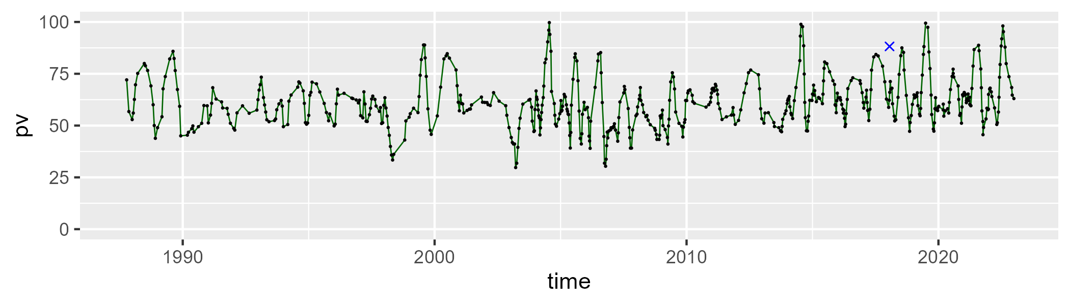

| Min. | 1st Qu. | Median | Mean | 3rd Qu. | Max. |
| --- | --- | --- | --- | --- | --- |
| 0 | 27.27002 | 33.85615 | 33.21409 | 40.12386 | 66.11654 |

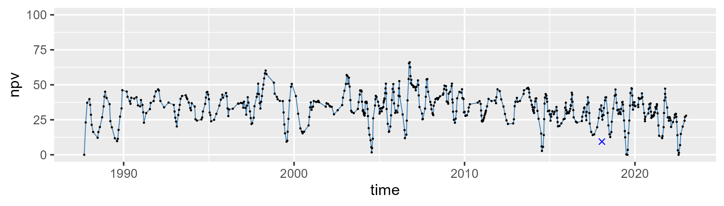

| Min. | 1st Qu. | Median | Mean | 3rd Qu. | Max. |
| --- | --- | --- | --- | --- | --- |
| 0 | 2.437978 | 4.088314 | 4.655353 | 6.105977 | 20.53117 |

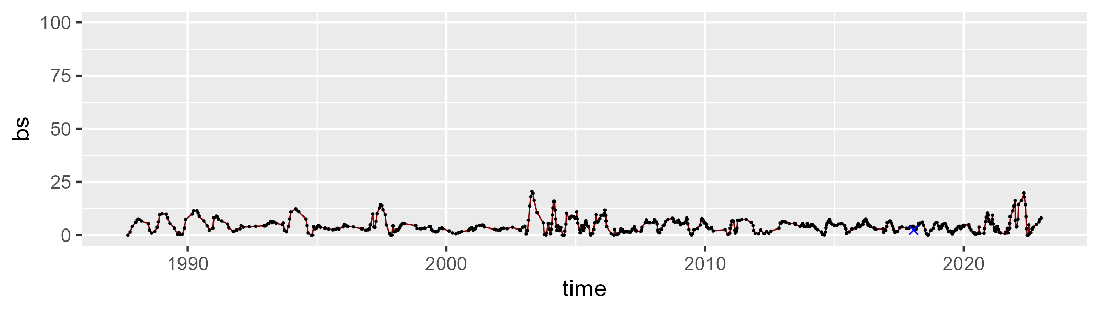

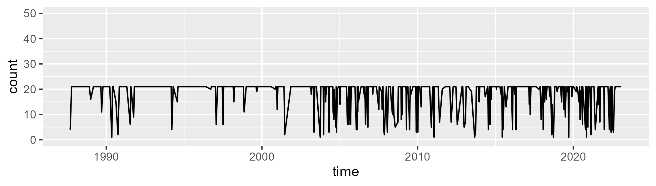

Min. : 1.00 1st Qu.:20.00 Median :21.00 Mean :18.32 3rd Qu.:21.00 Max. :21.00

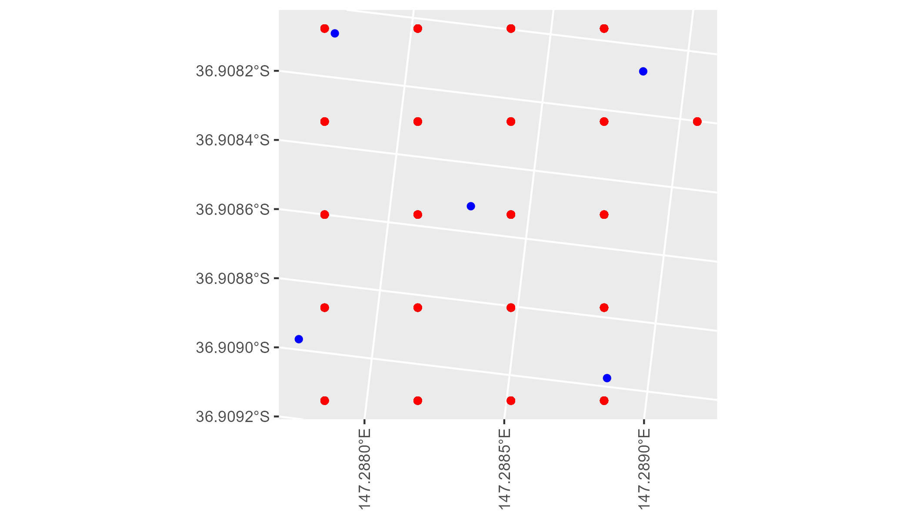

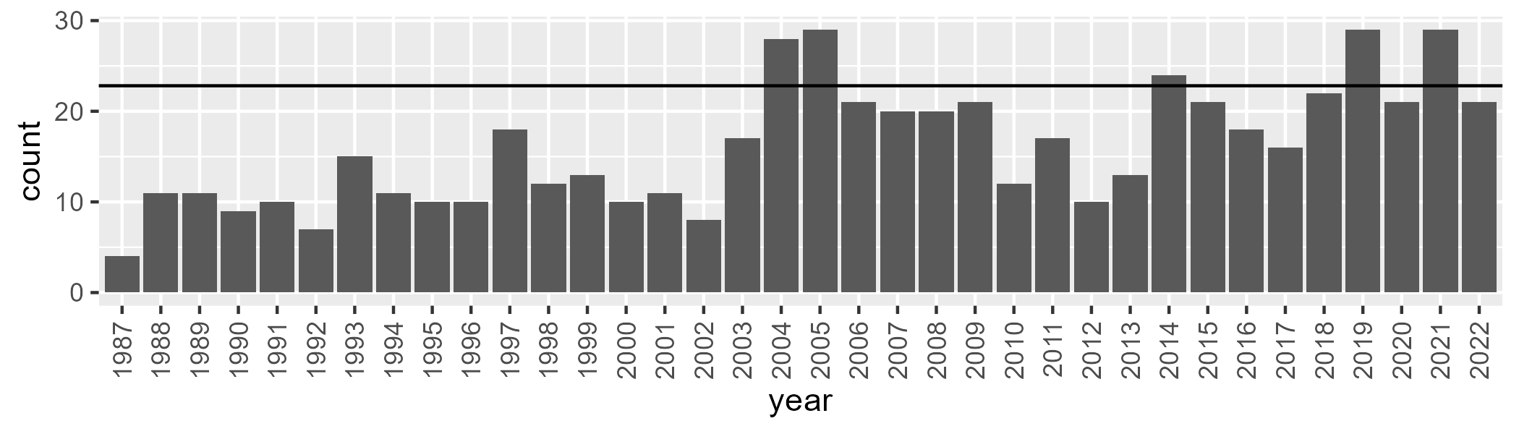

Number of samples: 579

# VCAAUA0002

| Min. | 1st Qu. | Median | Mean | 3rd Qu. | Max. |
| --- | --- | --- | --- | --- | --- |
| 28.94393 | 50.39985 | 57.29573 | 59.04169 | 65.07064 | 103.0888 |

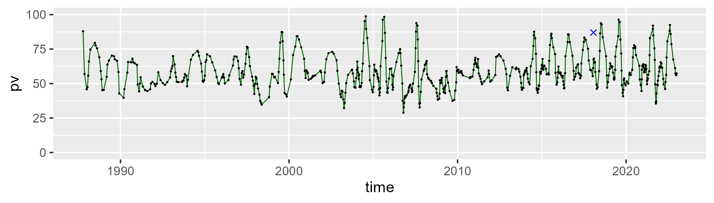

| Min. | 1st Qu. | Median | Mean | 3rd Qu. | Max. |
| --- | --- | --- | --- | --- | --- |
| 0 | 30.365 | 36.83893 | 36.09857 | 43.49095 | 66.25715 |

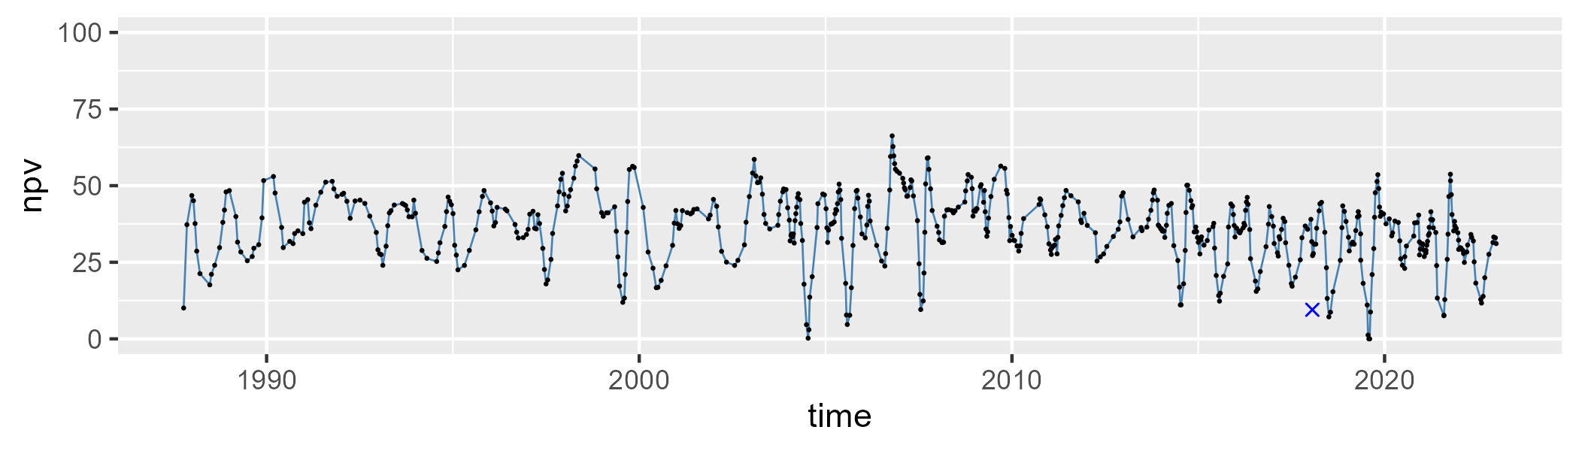

| Min. | 1st Qu. | Median | Mean | 3rd Qu. | Max. |
| --- | --- | --- | --- | --- | --- |
| 0 | 2.383429 | 3.879209 | 4.292734 | 5.585917 | 17.97225 |

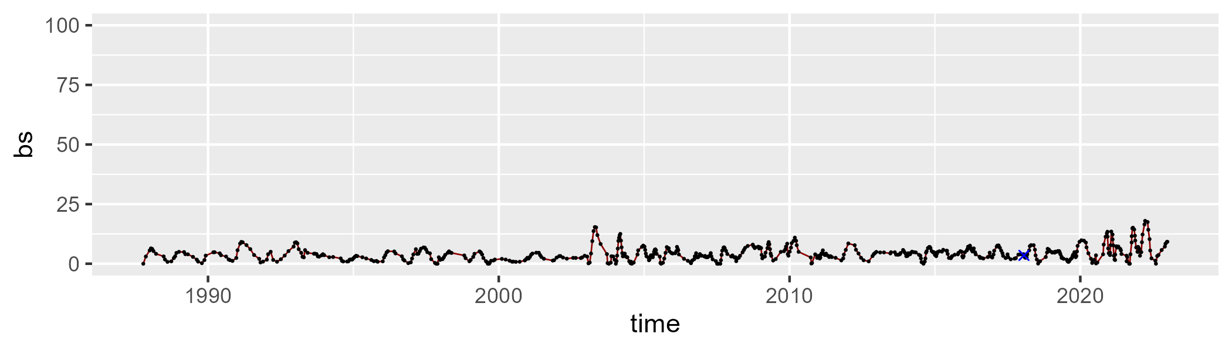

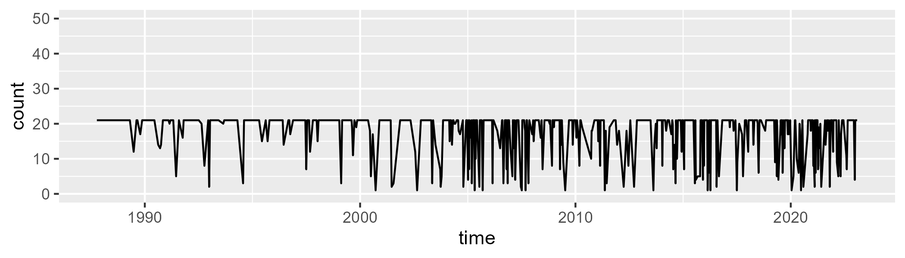

Min. : 1.00 1st Qu.:18.00 Median :21.00 Mean :17.85 3rd Qu.:21.00 Max. :21.00

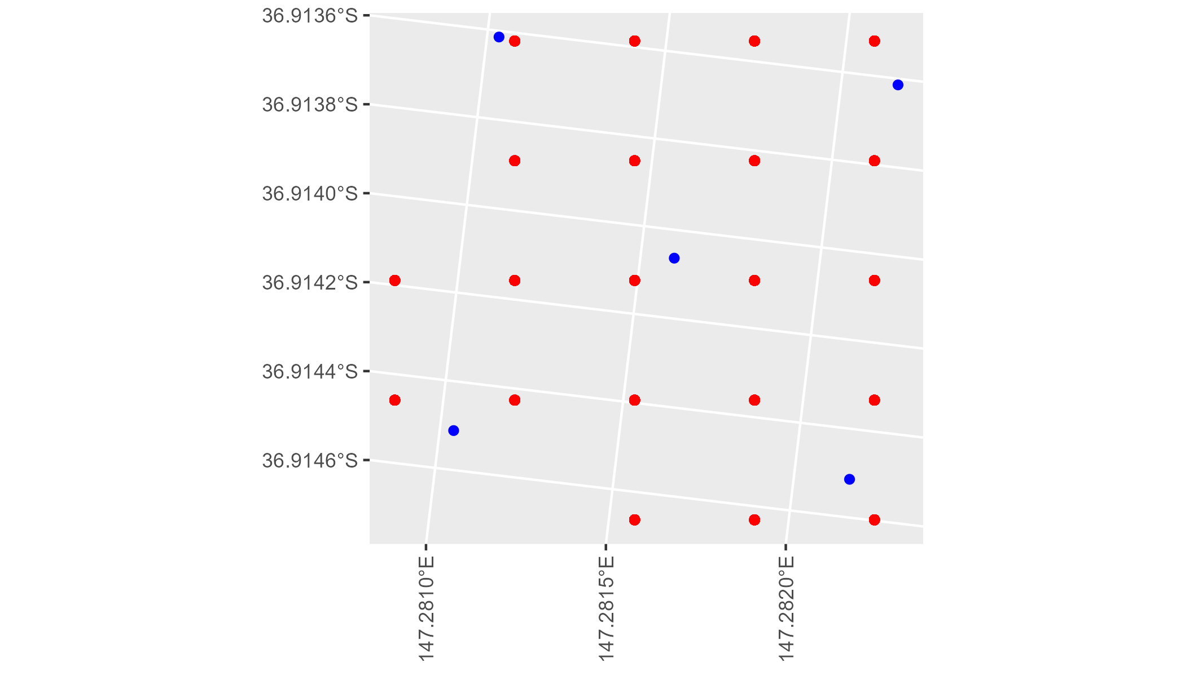

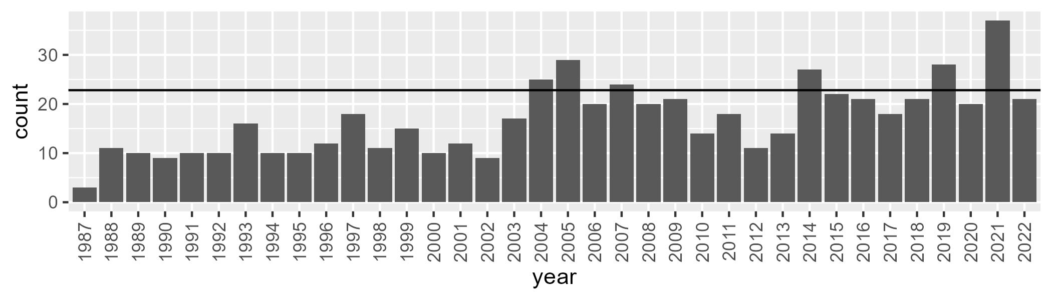

Number of samples: 604

# VCAAUA0003

| Min. | 1st Qu. | Median | Mean | 3rd Qu. | Max. |
| --- | --- | --- | --- | --- | --- |
| 35.73501 | 59.43954 | 64.80349 | 66.58376 | 74.10751 | 103.5966 |

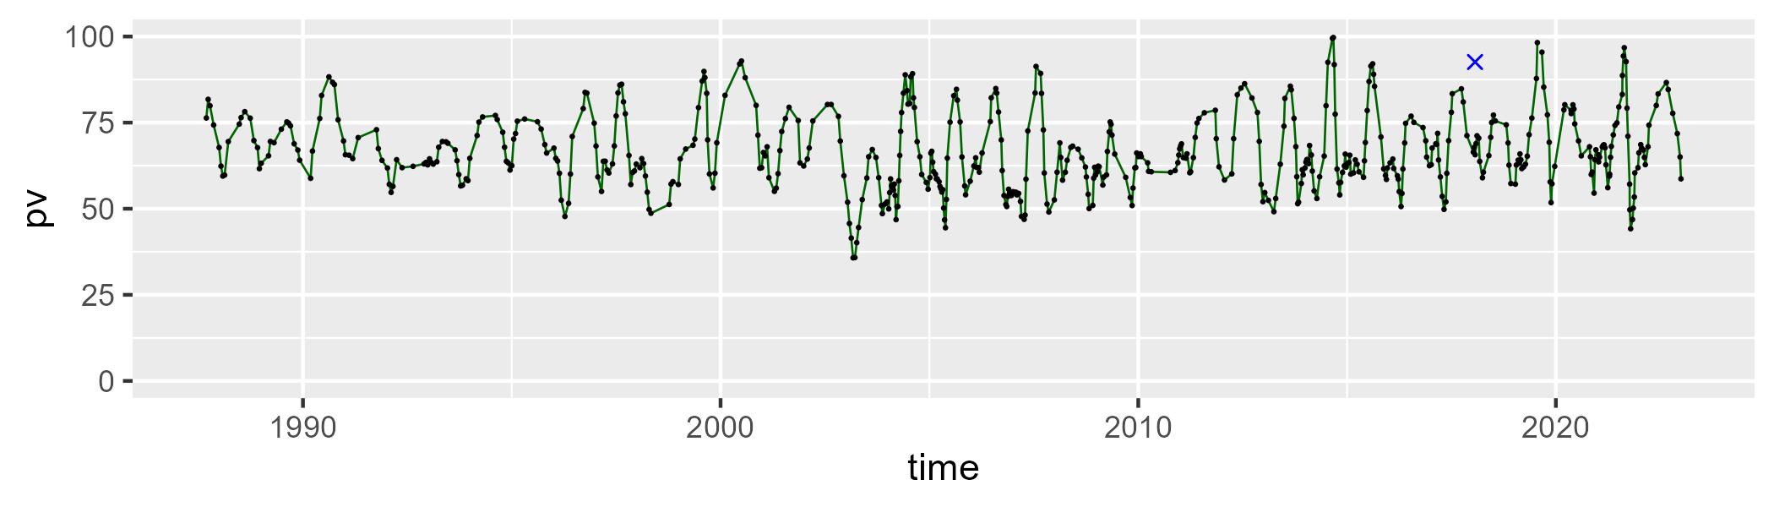

| Min. | 1st Qu. | Median | Mean | 3rd Qu. | Max. |
| --- | --- | --- | --- | --- | --- |
| 0 | 24.33508 | 30.78917 | 29.4613 | 35.11651 | 49.66492 |

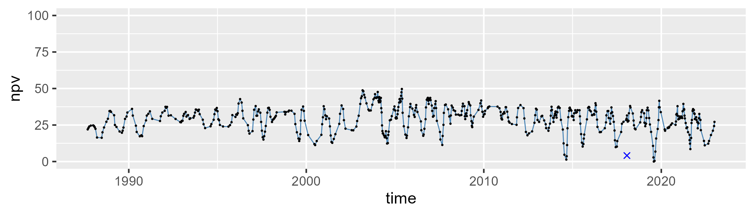

| Min. | 1st Qu. | Median | Mean | 3rd Qu. | Max. |
| --- | --- | --- | --- | --- | --- |
| 0 | 0.9558201 | 2.745561 | 4.100645 | 5.474882 | 26.40174 |

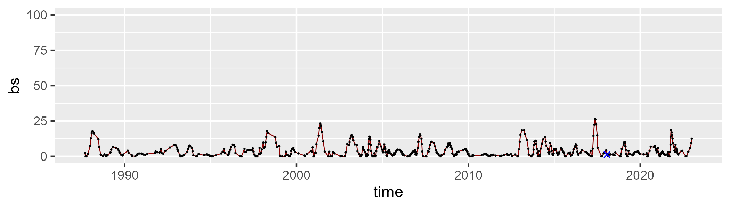

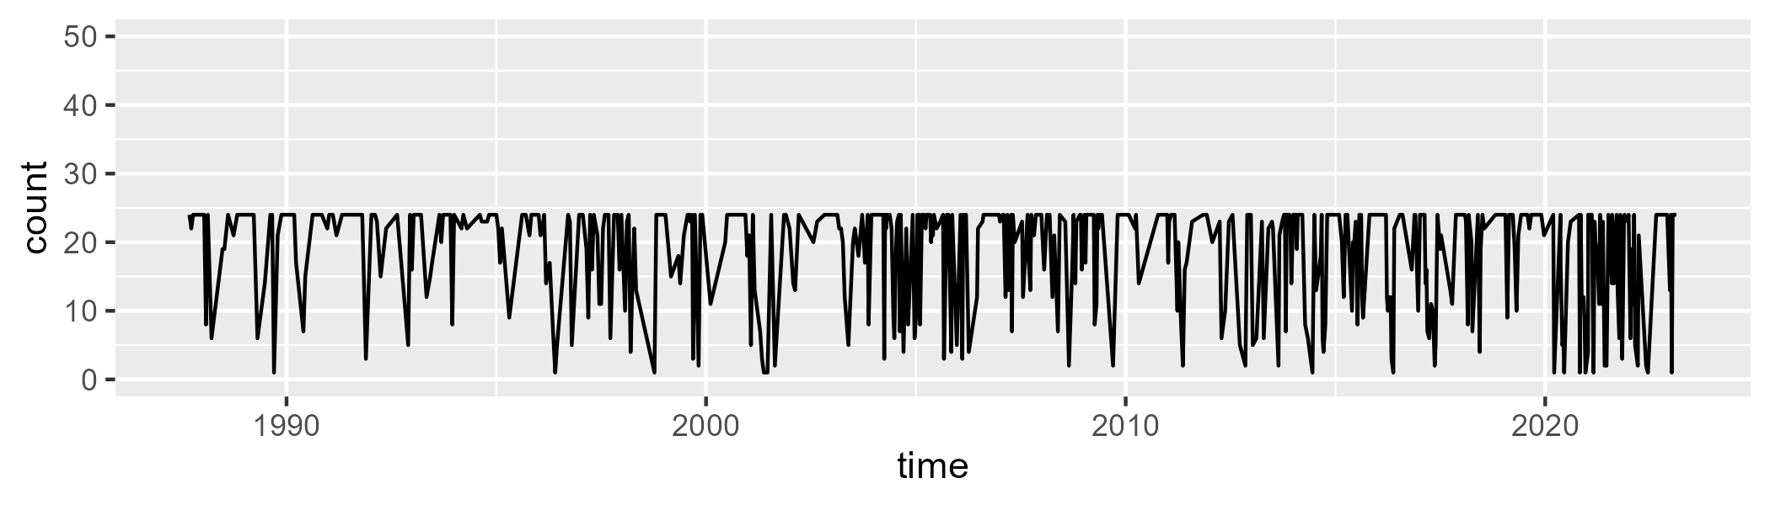

Min. : 1.00 1st Qu.:14.00 Median :24.00 Mean :18.87 3rd Qu.:24.00 Max. :24.00

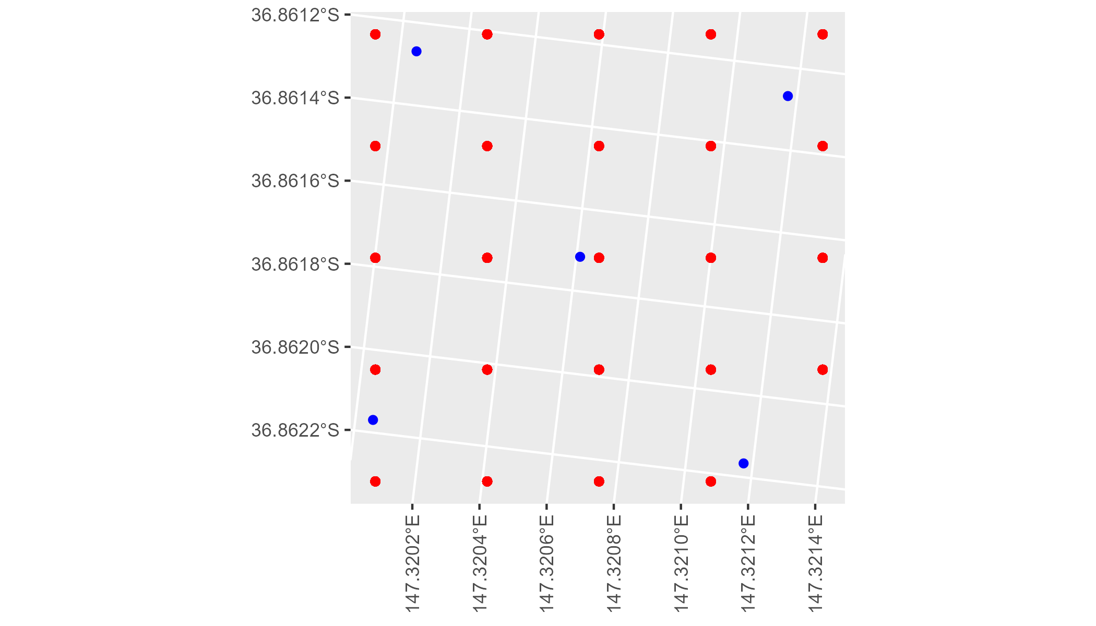

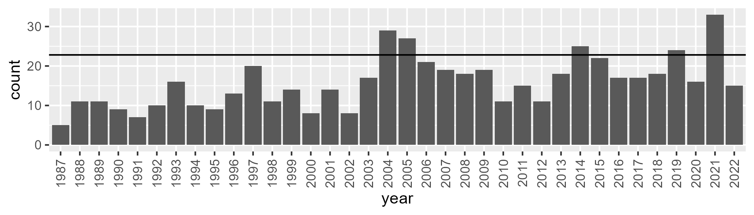

Number of samples: 568

# VCAAUA0004

| Min. | 1st Qu. | Median | Mean | 3rd Qu. | Max. |
| --- | --- | --- | --- | --- | --- |
| 42.22153 | 60.48352 | 66.56299 | 68.2885 | 74.20449 | 107.8519 |

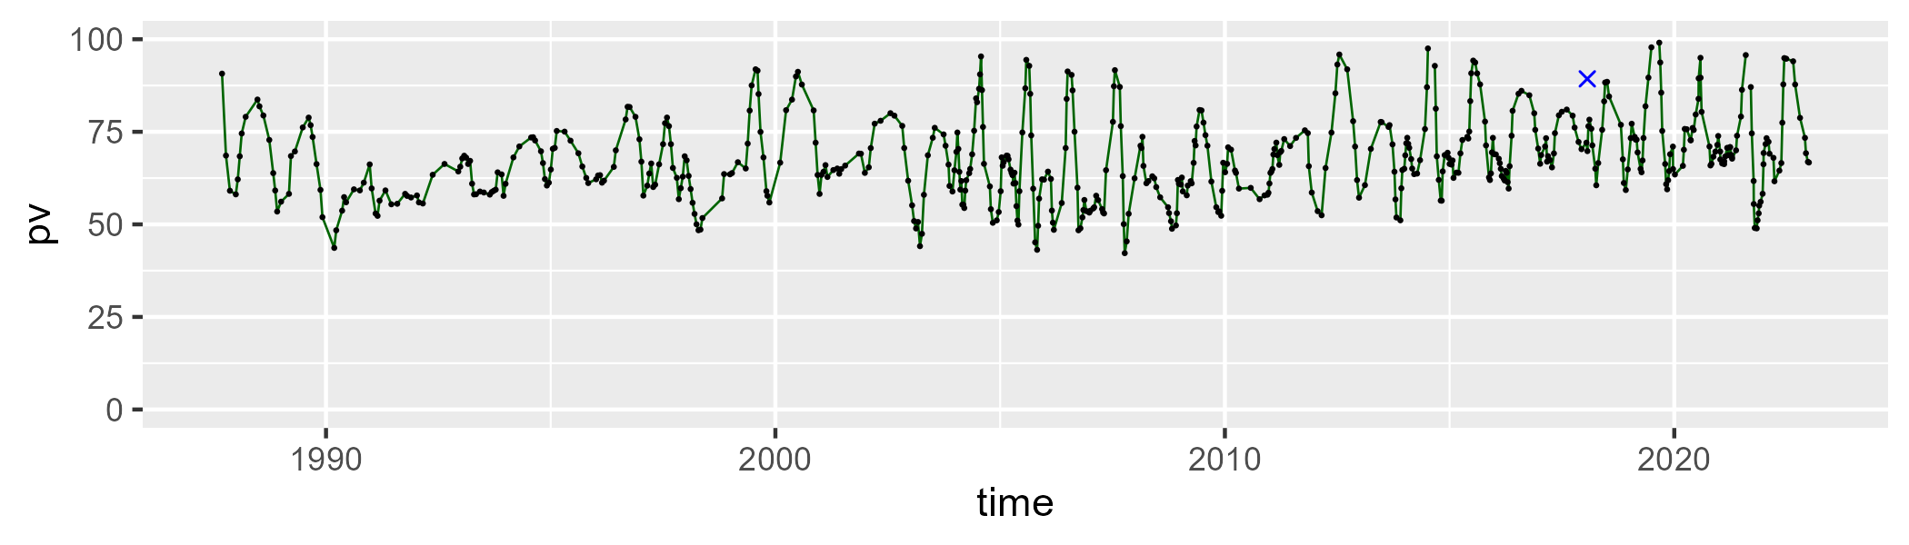

| Min. | 1st Qu. | Median | Mean | 3rd Qu. | Max. |
| --- | --- | --- | --- | --- | --- |
| 0 | 23.94348 | 29.09744 | 28.81397 | 35.33063 | 51.21622 |

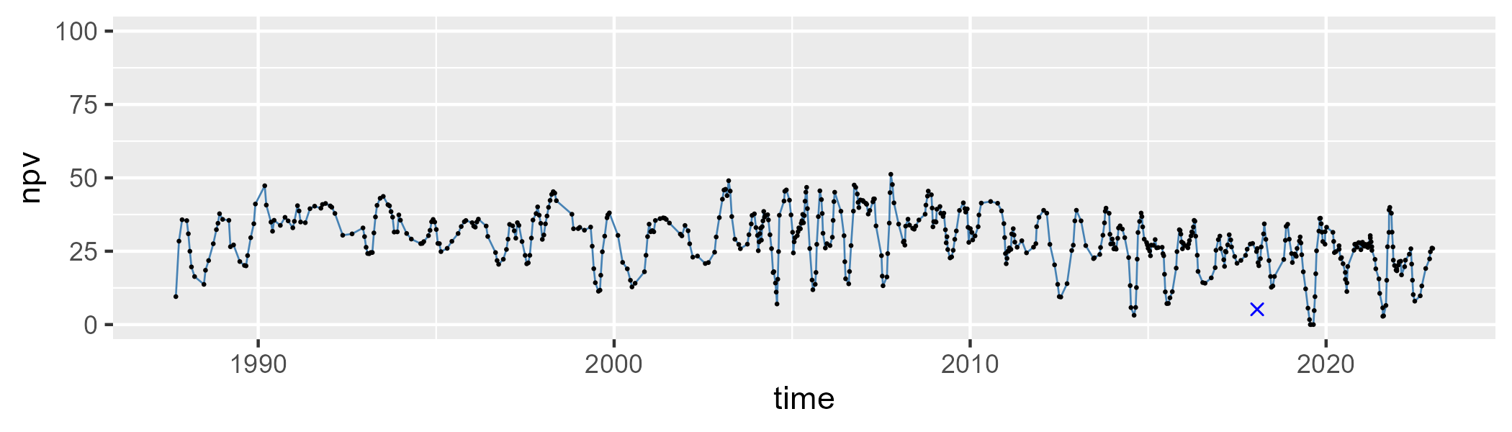

| Min. | 1st Qu. | Median | Mean | 3rd Qu. | Max. |
| --- | --- | --- | --- | --- | --- |
| 0 | 0.8964101 | 2.240062 | 3.056366 | 4.494812 | 22.59263 |

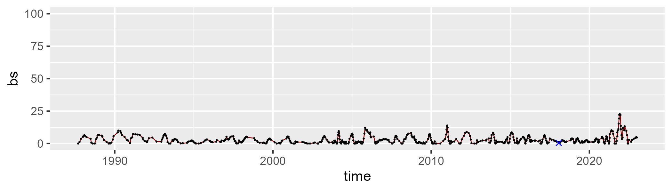

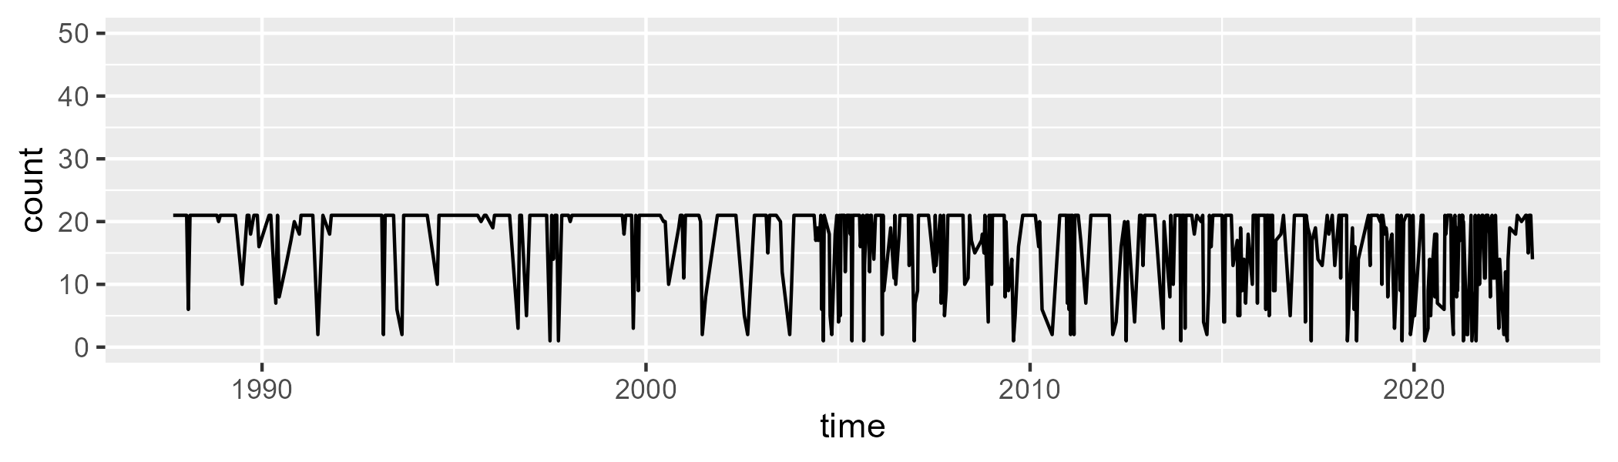

Min. : 1.00 1st Qu.:14.00 Median :21.00 Mean :17.03 3rd Qu.:21.00 Max. :21.00

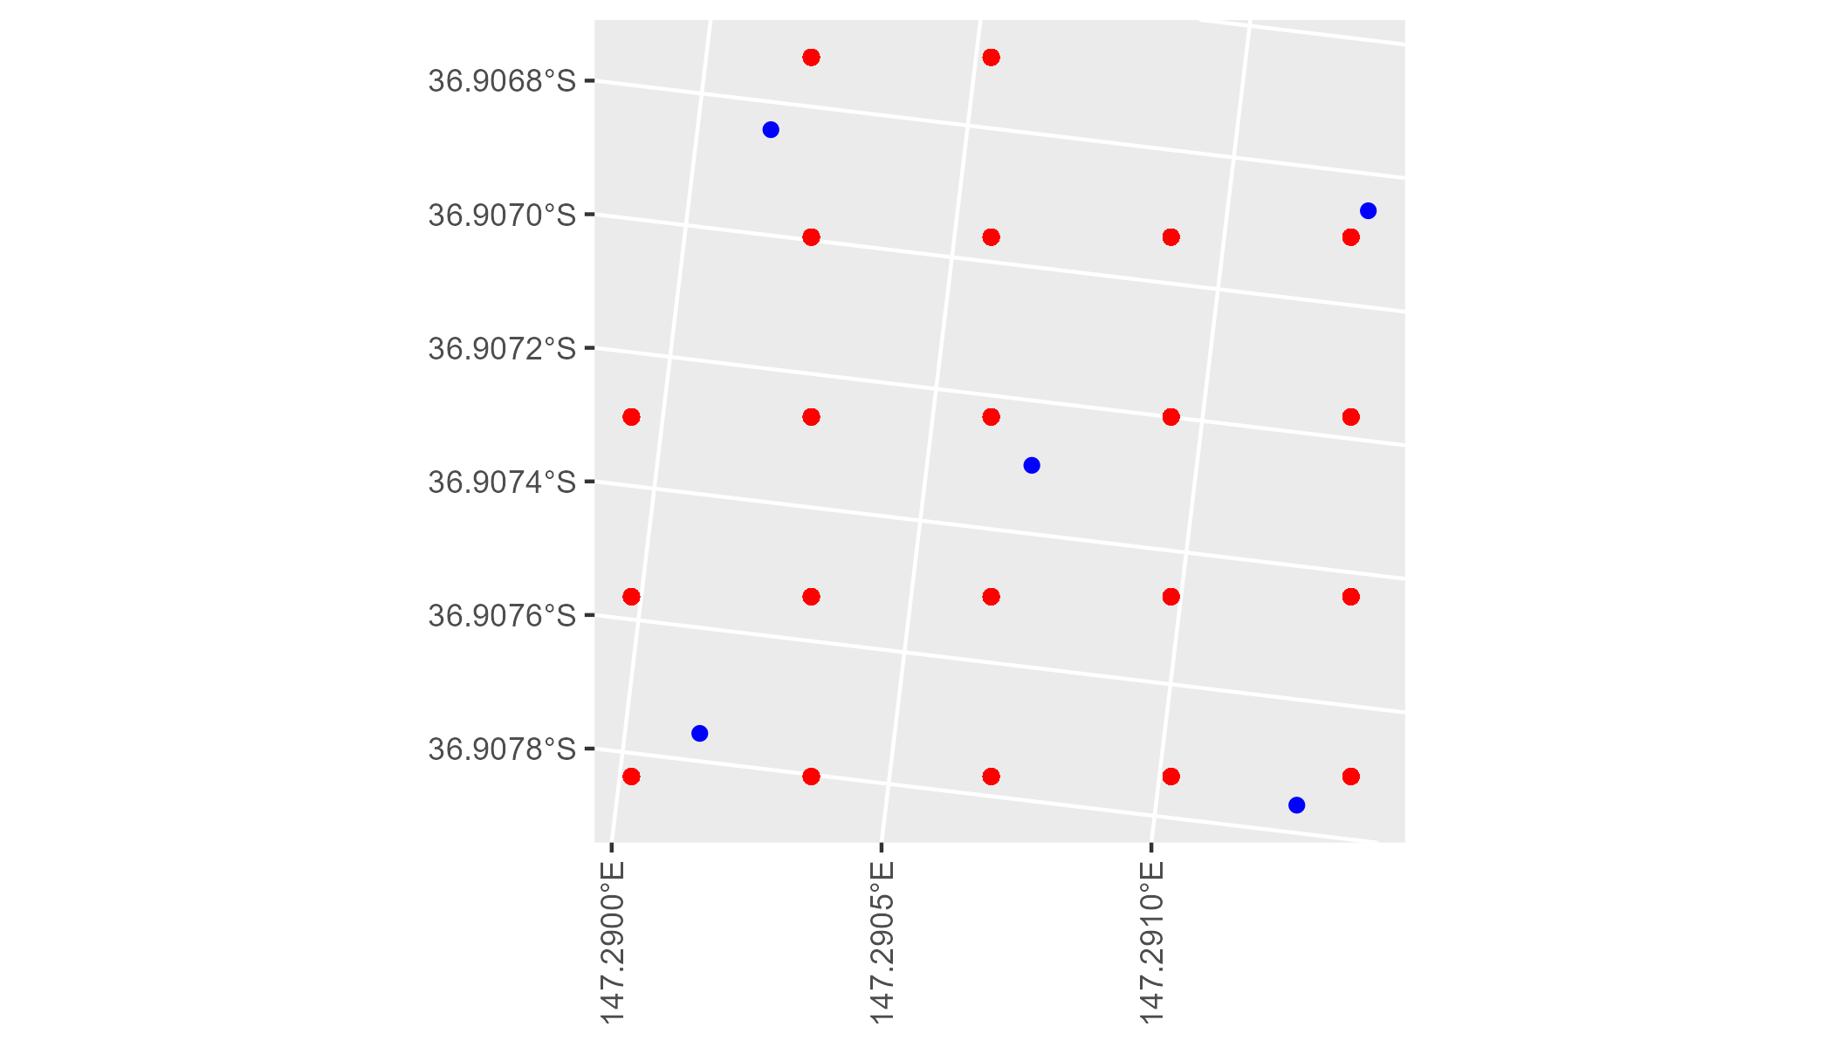

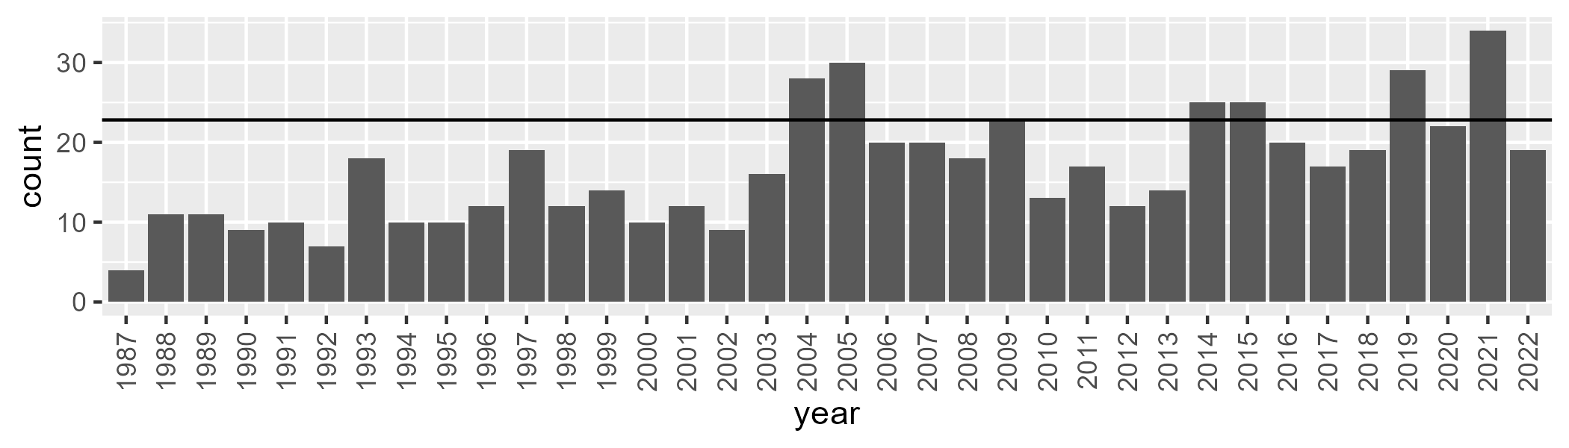

Number of samples: 599

# VCAAUA0005

| Min. | 1st Qu. | Median | Mean | 3rd Qu. | Max. |
| --- | --- | --- | --- | --- | --- |
| 3.055532 | 51.85745 | 57.99927 | 58.93777 | 65.46156 | 105.9825 |

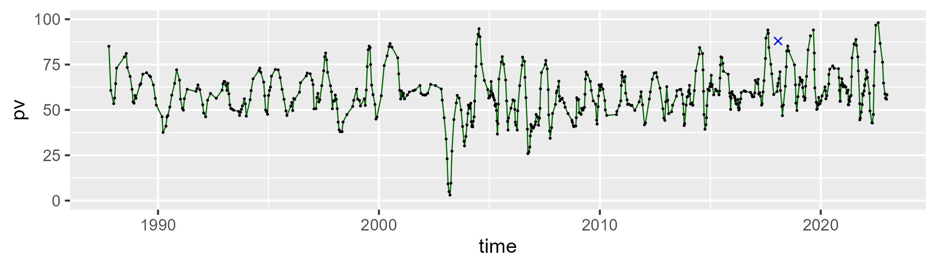

| Min. | 1st Qu. | Median | Mean | 3rd Qu. | Max. |
| --- | --- | --- | --- | --- | --- |
| 0 | 28.26258 | 34.68393 | 34.34252 | 40.71861 | 67.39115 |

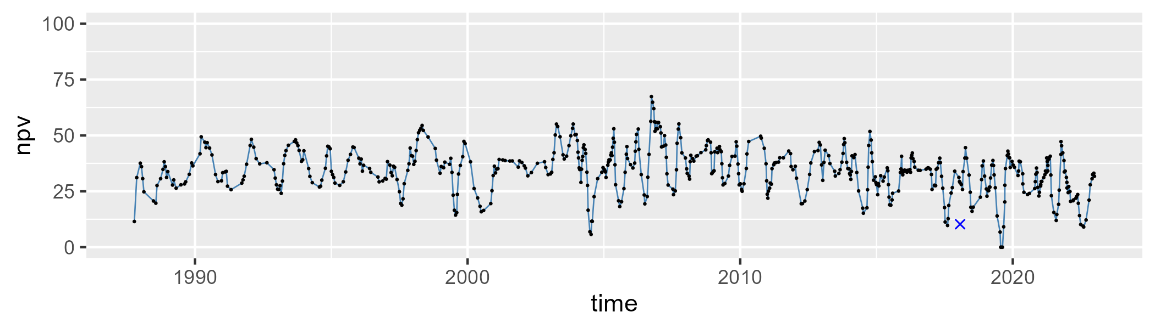

| Min. | 1st Qu. | Median | Mean | 3rd Qu. | Max. |
| --- | --- | --- | --- | --- | --- |
| 0 | 3.42197 | 5.397503 | 6.310779 | 7.565698 | 51.24962 |

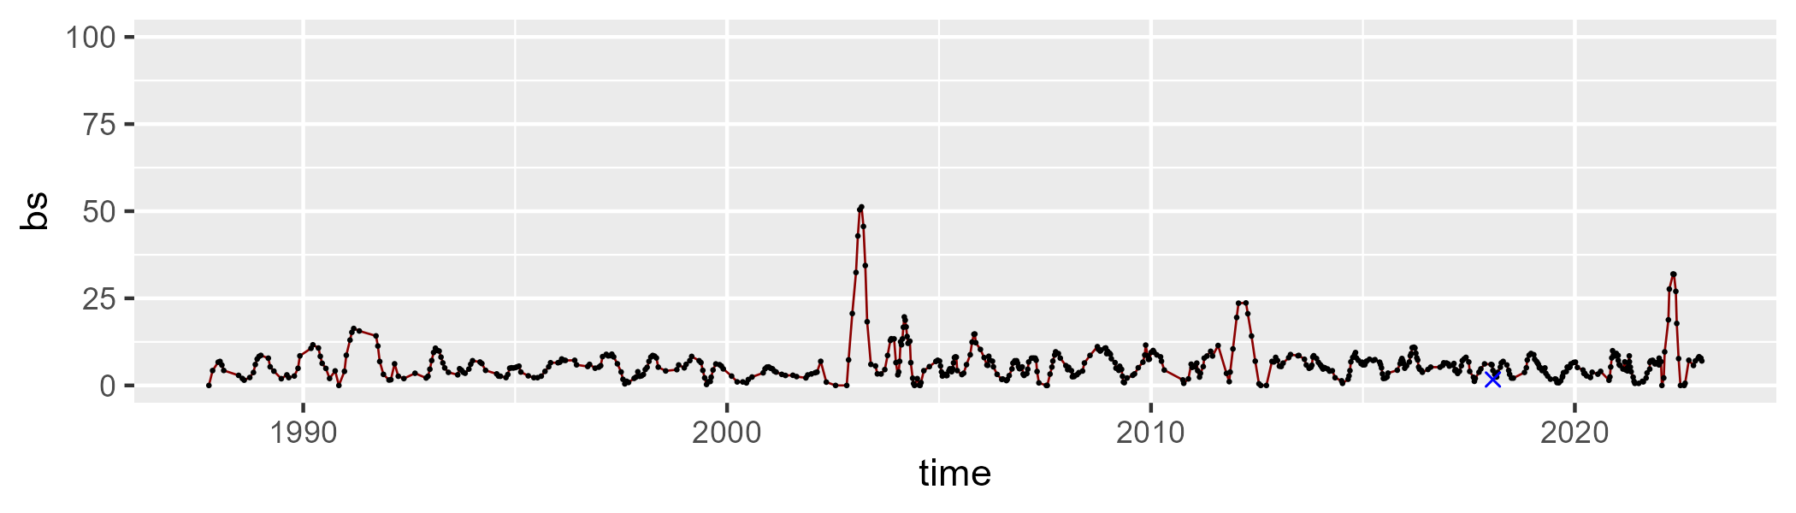

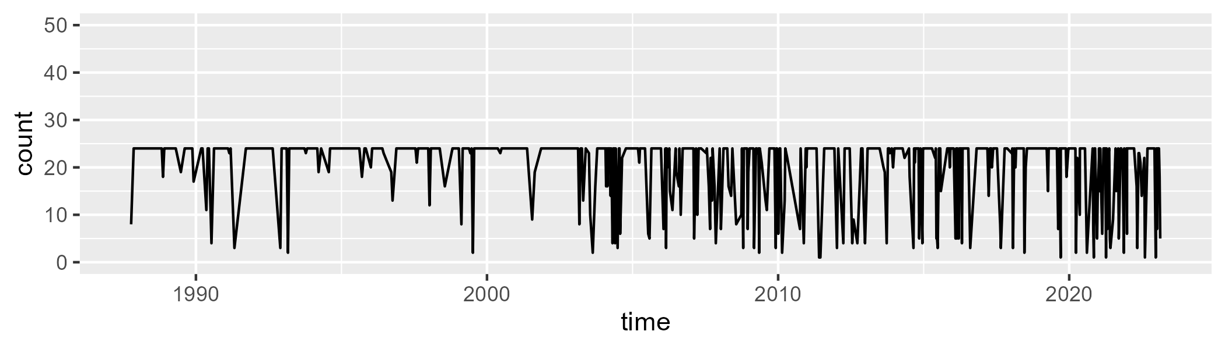

Min. : 1.0 1st Qu.:22.0 Median :24.0 Mean :20.5 3rd Qu.:24.0 Max. :24.0

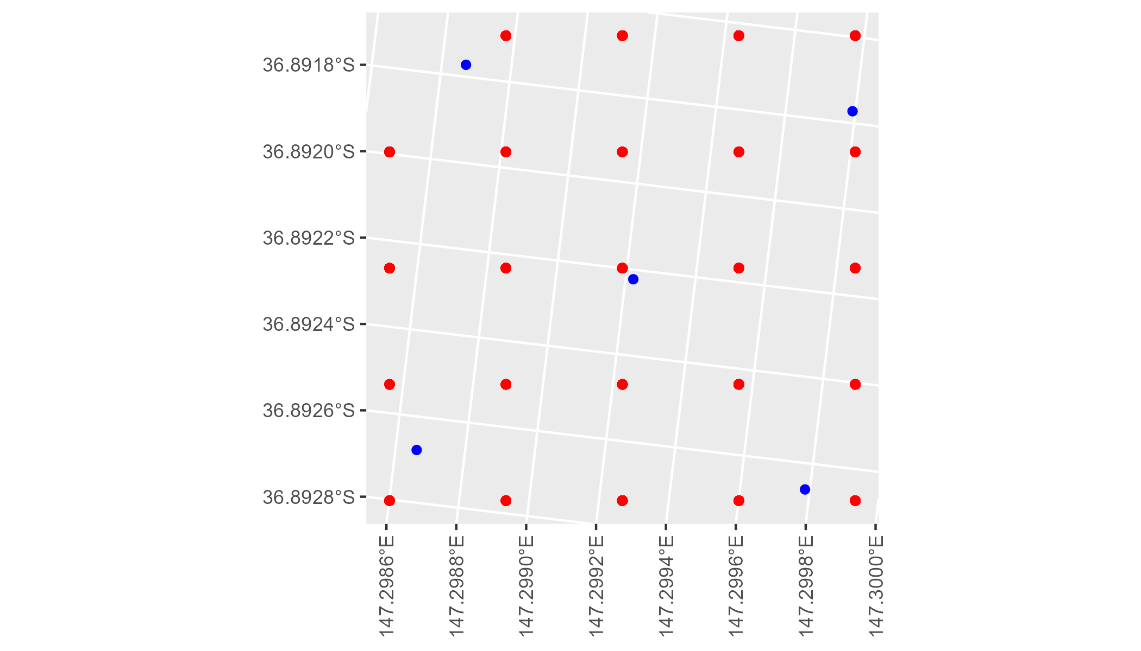

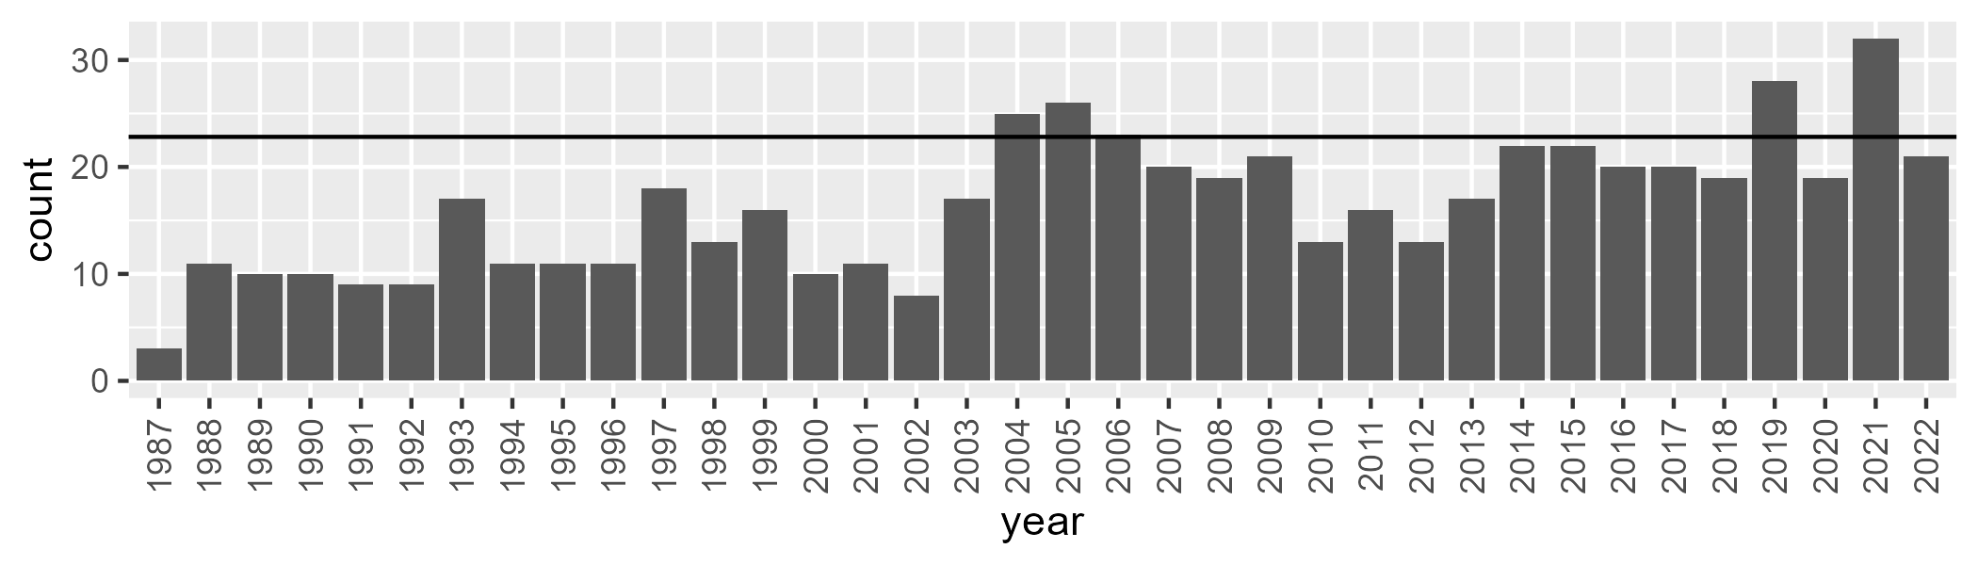

Number of samples: 591

# VCAAUA0006

| Min. | 1st Qu. | Median | Mean | 3rd Qu. | Max. |
| --- | --- | --- | --- | --- | --- |
| 25.29287 | 51.30516 | 59.267 | 61.43792 | 68.17923 | 114.7657 |

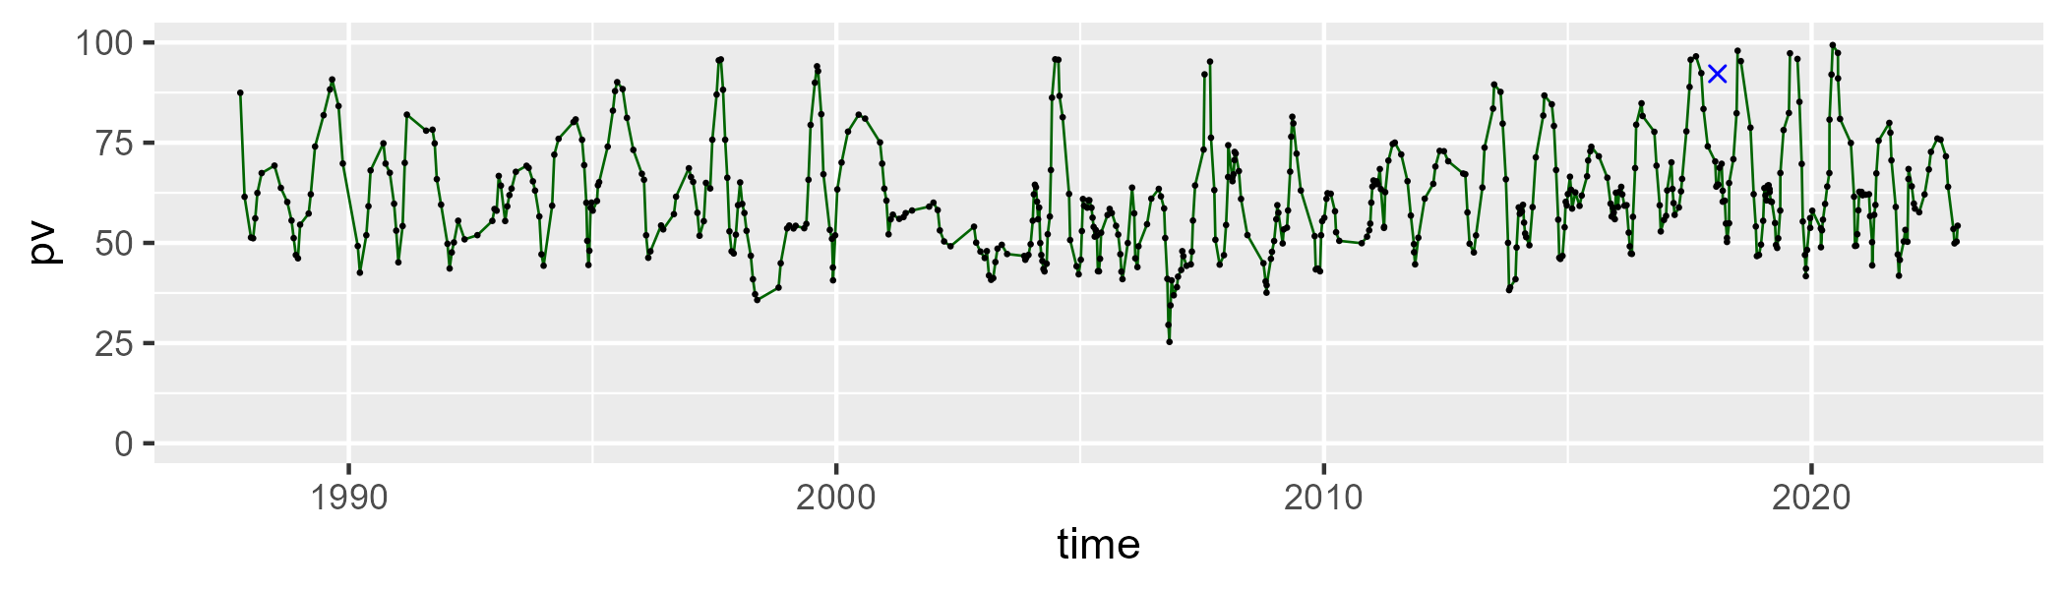

| Min. | 1st Qu. | Median | Mean | 3rd Qu. | Max. |
| --- | --- | --- | --- | --- | --- |
| 0 | 27.7801 | 34.7678 | 33.37249 | 41.52352 | 67.54236 |

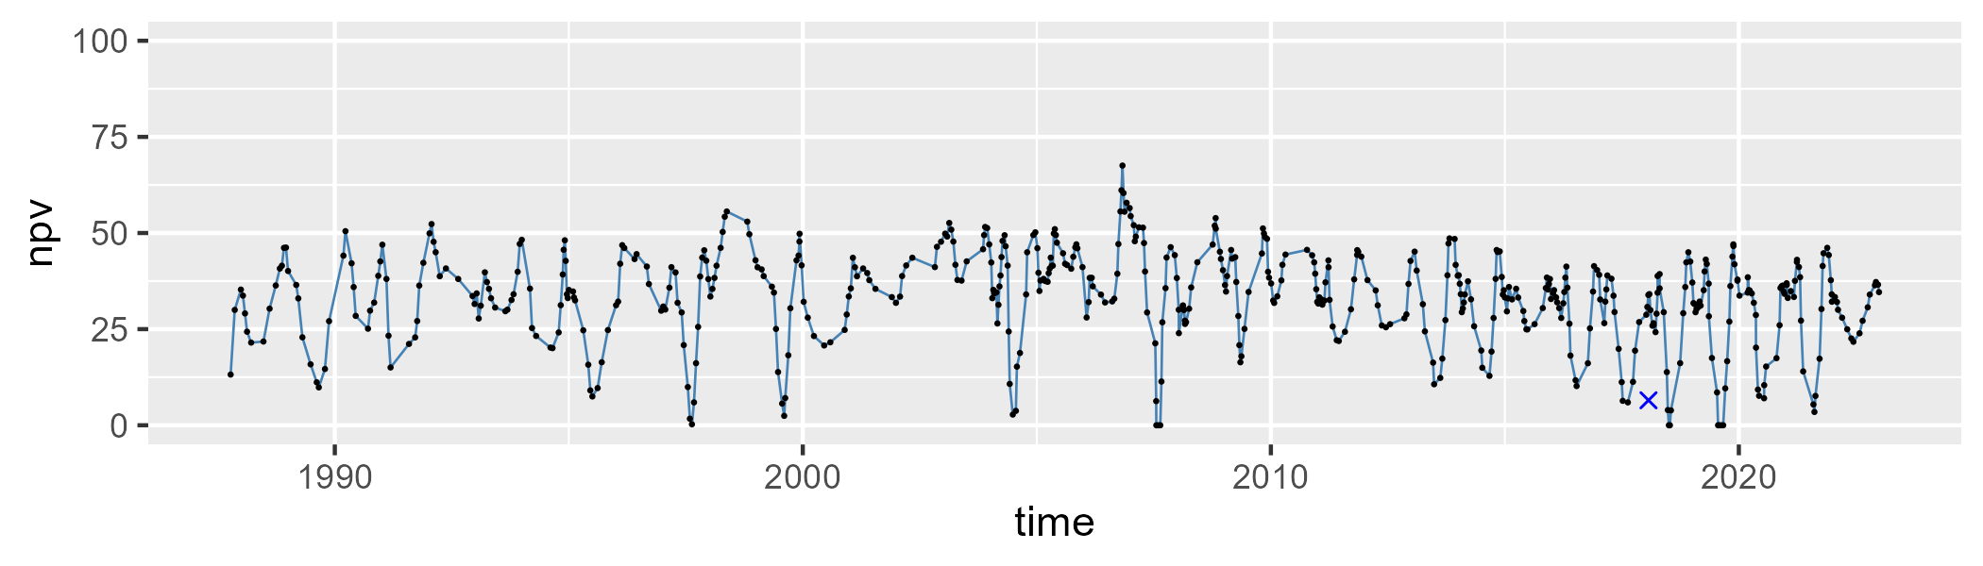

| Min. | 1st Qu. | Median | Mean | 3rd Qu. | Max. |
| --- | --- | --- | --- | --- | --- |
| 0 | 2.139762 | 3.891871 | 4.621646 | 6.442932 | 17.3153 |

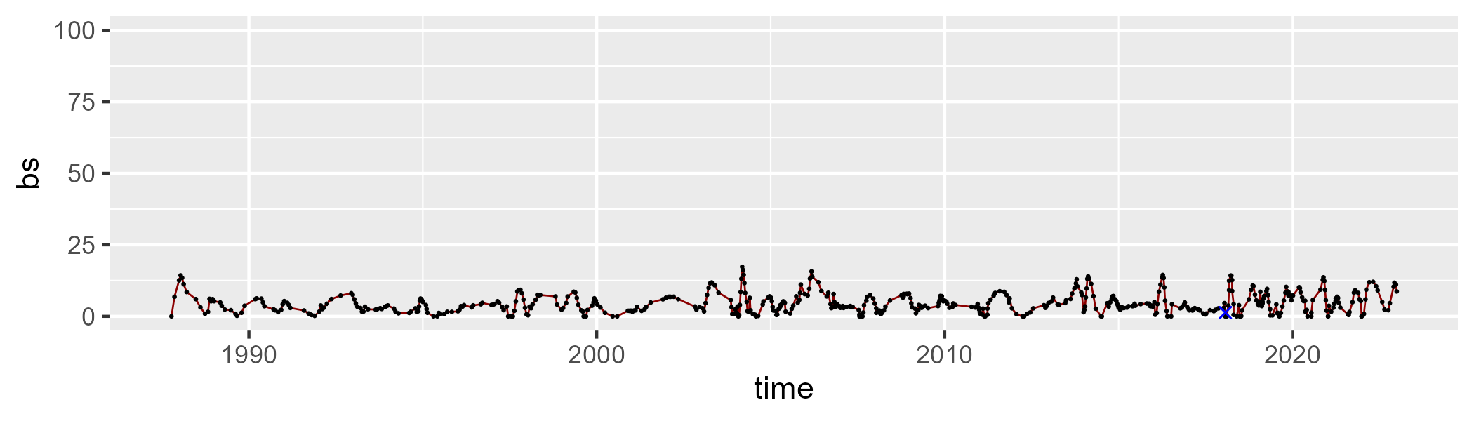

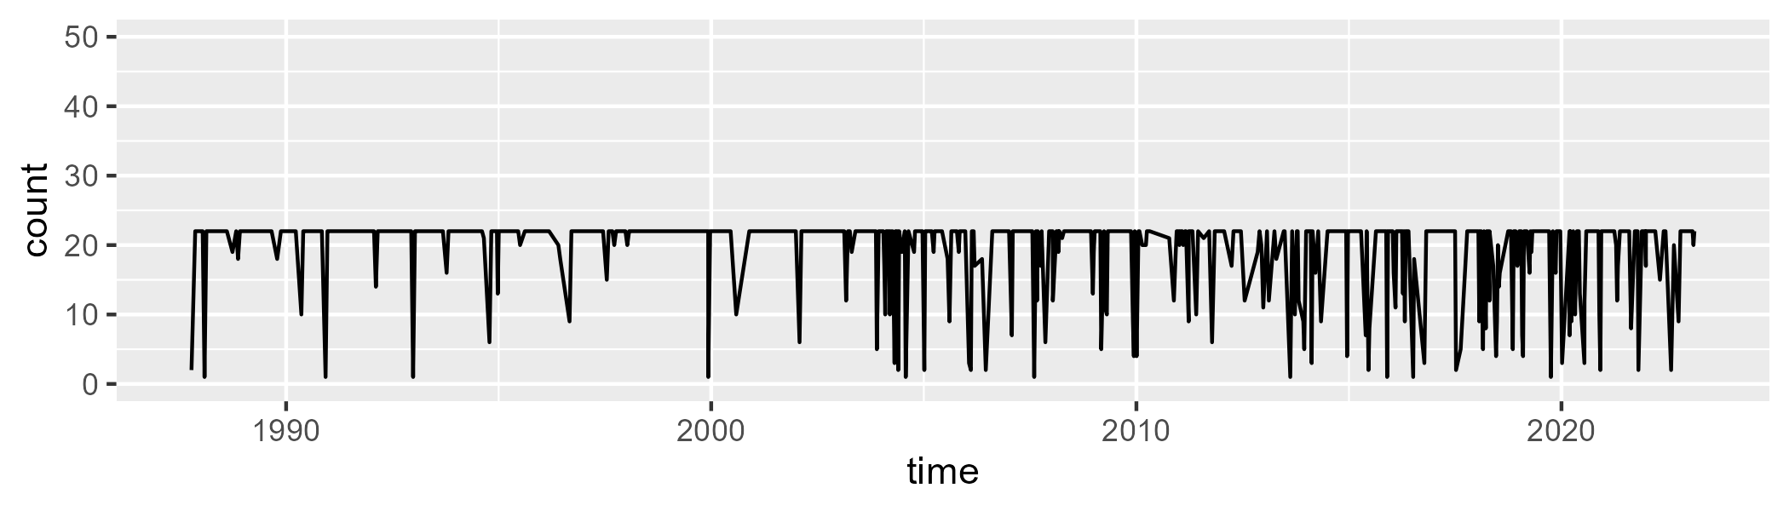

Min. : 1.00 1st Qu.:22.00 Median :22.00 Mean :19.35 3rd Qu.:22.00 Max. :22.00

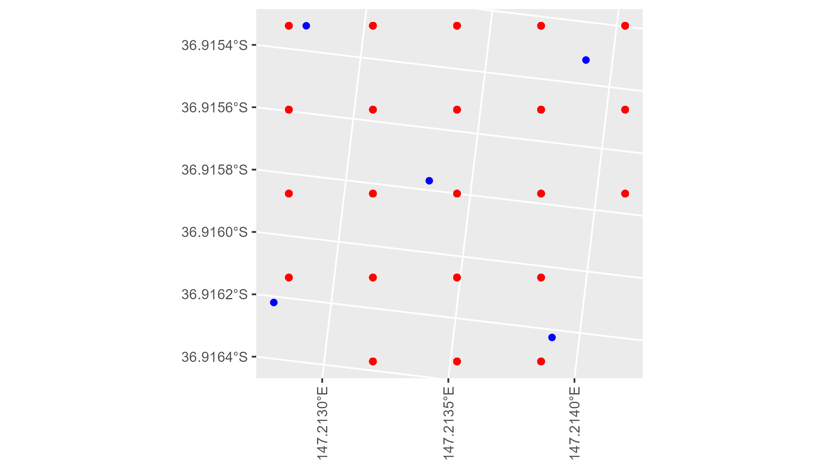

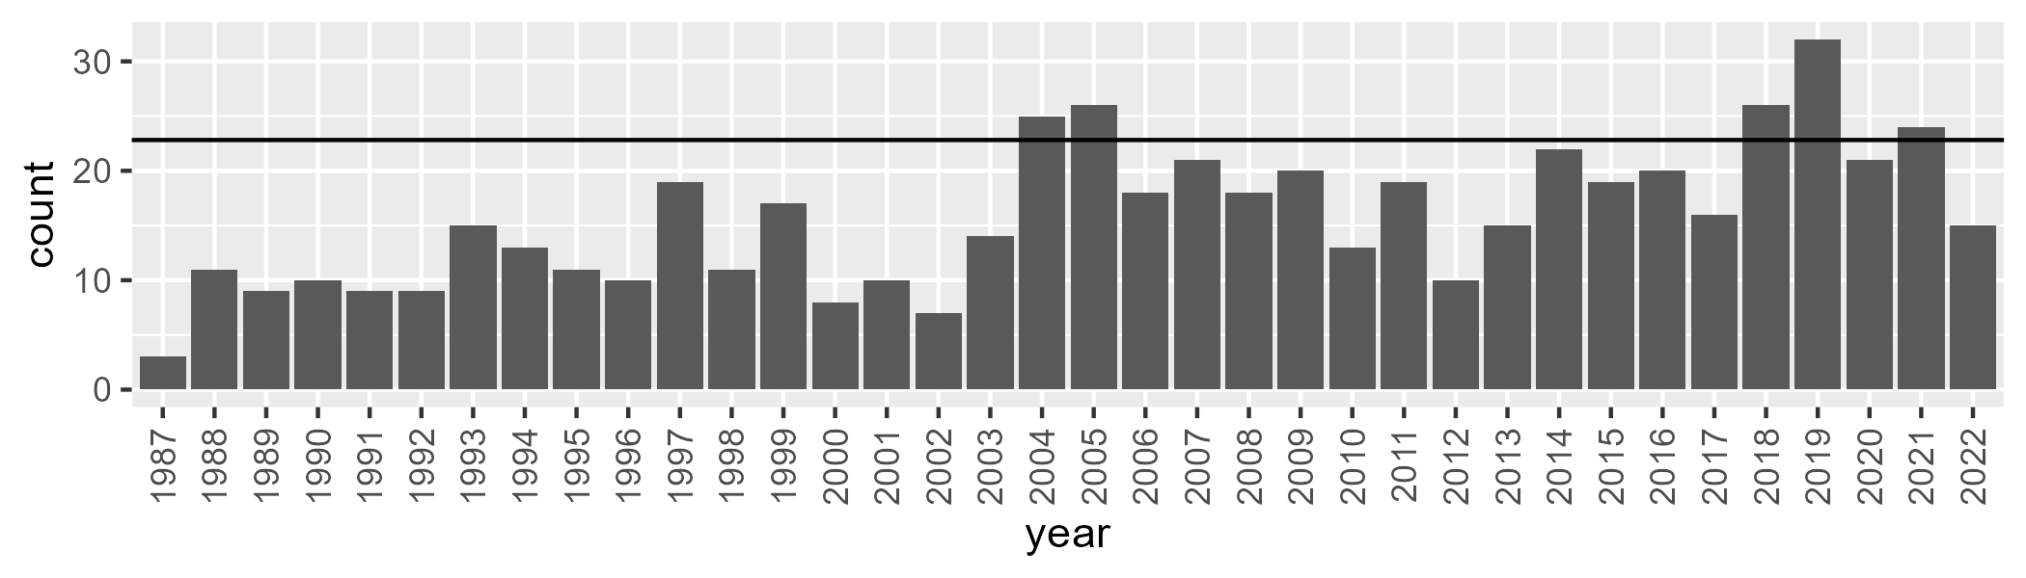

Number of samples: 566

# VCAAUA0007

| Min. | 1st Qu. | Median | Mean | 3rd Qu. | Max. |
| --- | --- | --- | --- | --- | --- |
| 25.52623 | 52.51701 | 59.04607 | 60.72362 | 67.51147 | 109.243 |

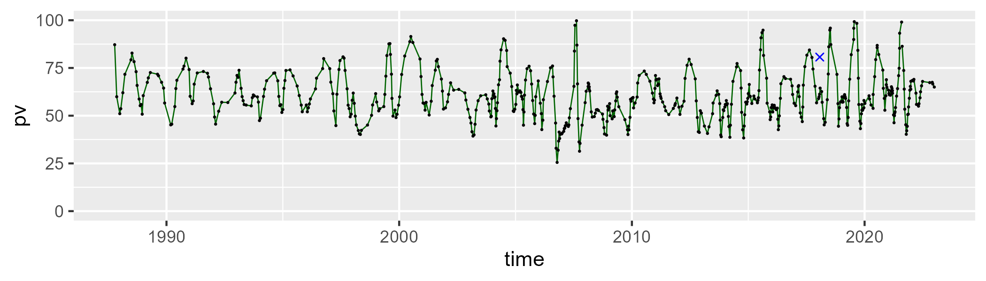

| Min. | 1st Qu. | Median | Mean | 3rd Qu. | Max. |
| --- | --- | --- | --- | --- | --- |
| 0 | 26.94928 | 34.59155 | 33.92401 | 40.96469 | 70.48286 |

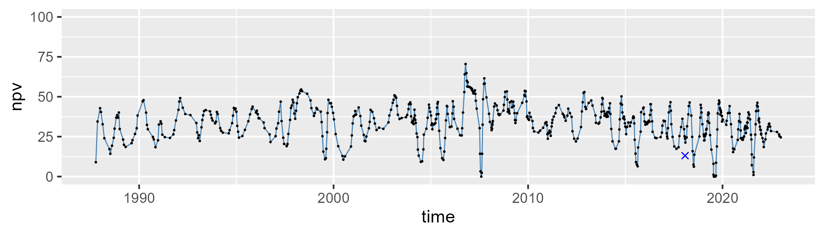

| Min. | 1st Qu. | Median | Mean | 3rd Qu. | Max. |
| --- | --- | --- | --- | --- | --- |
| 0 | 2.359342 | 3.898308 | 4.880296 | 6.299291 | 19.6373 |

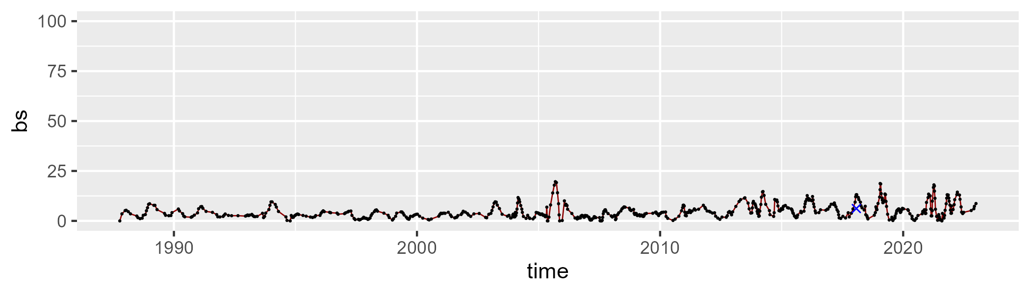

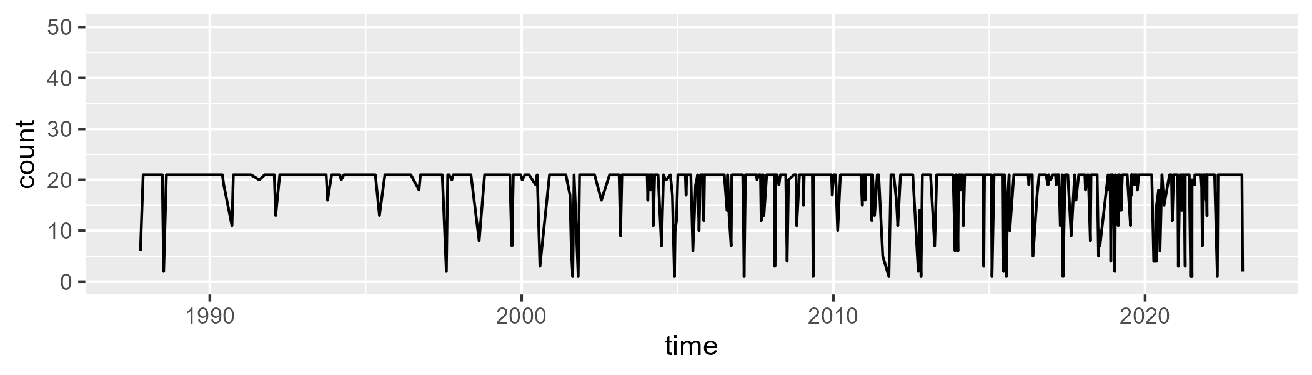

Min. : 1.0 1st Qu.:21.0 Median :21.0 Mean :18.9 3rd Qu.:21.0 Max. :21.0

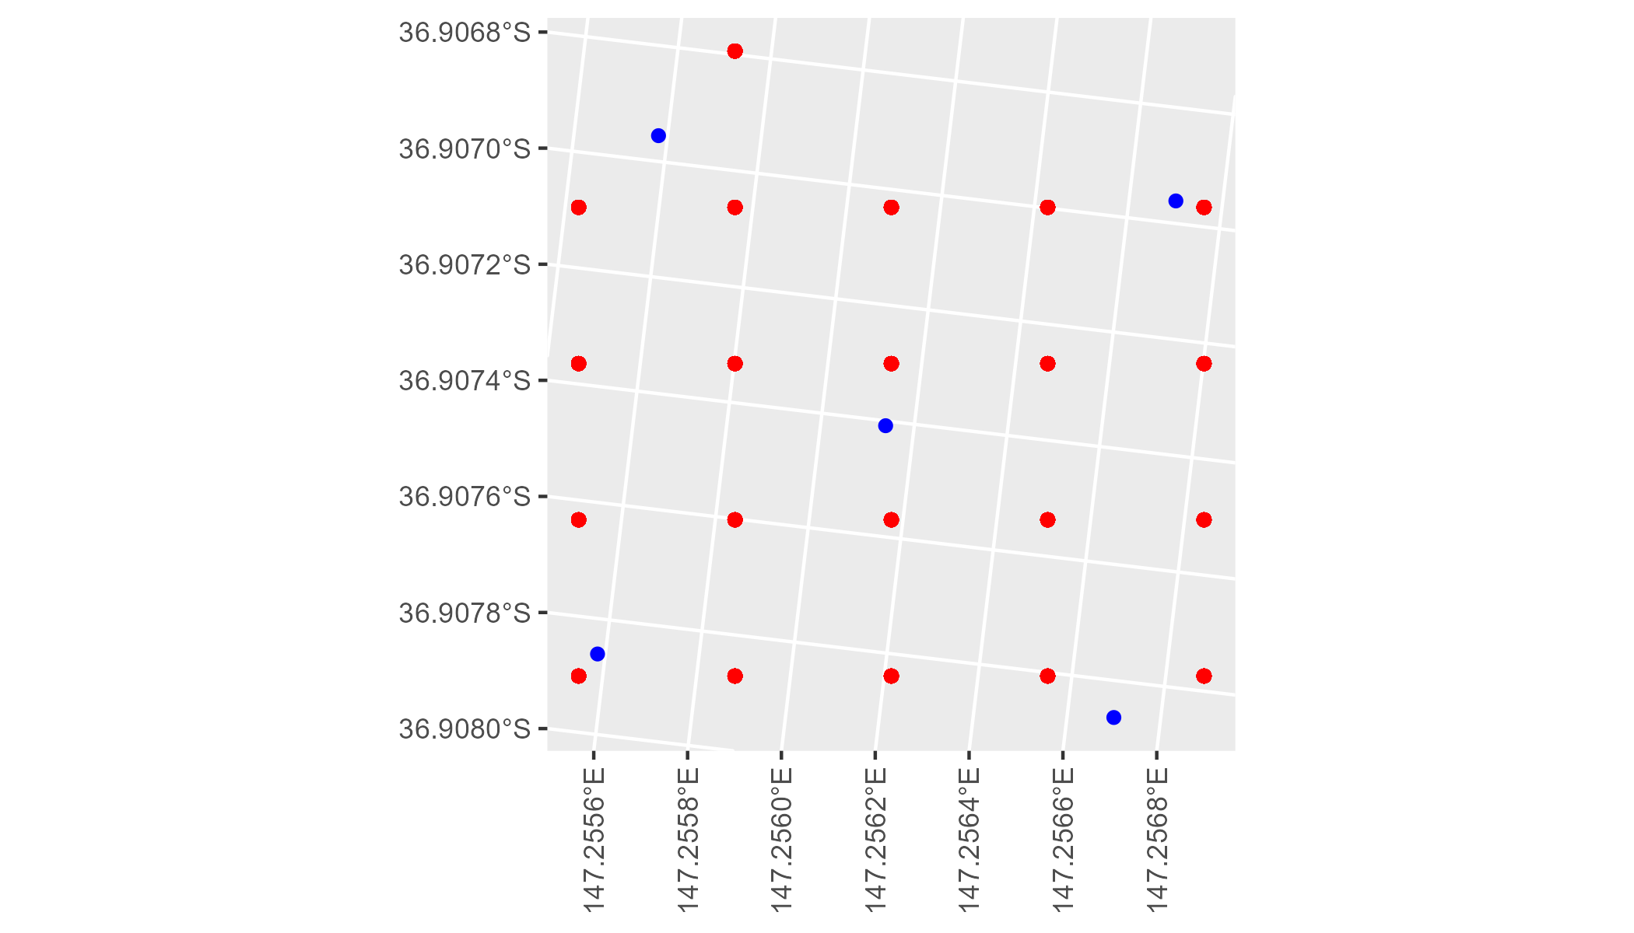

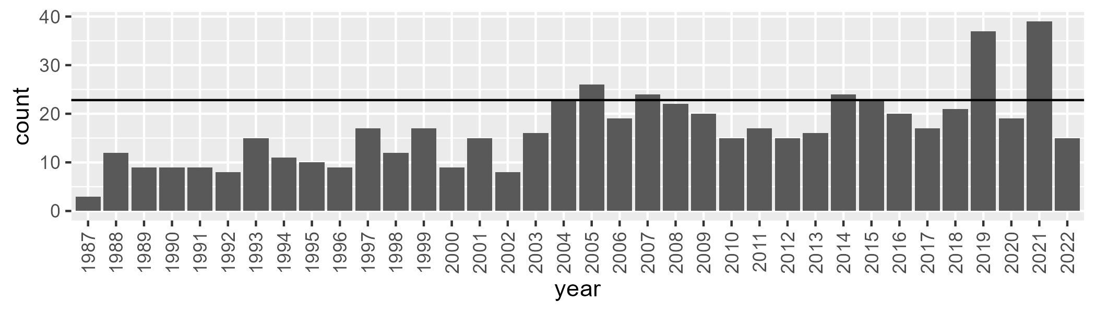

Number of samples: 601

# VCAAUA0008

| Min. | 1st Qu. | Median | Mean | 3rd Qu. | Max. |
| --- | --- | --- | --- | --- | --- |
| 44.46175 | 58.21584 | 62.87755 | 66.34886 | 72.48784 | 105.5654 |

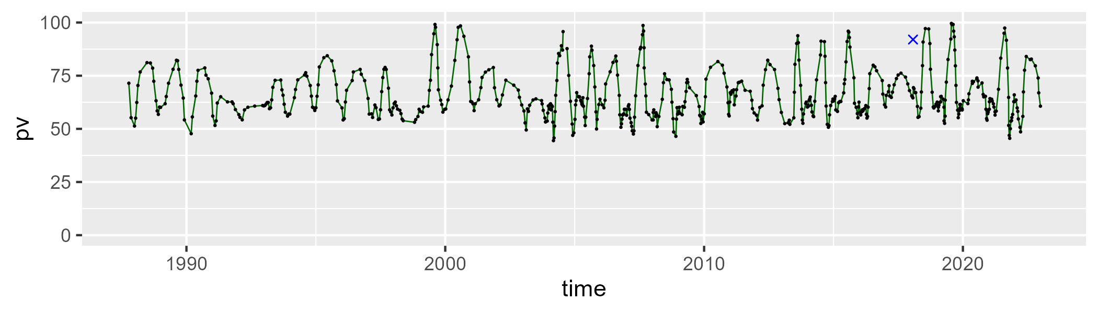

| Min. | 1st Qu. | Median | Mean | 3rd Qu. | Max. |
| --- | --- | --- | --- | --- | --- |
| 0 | 24.3136 | 31.52268 | 29.23973 | 35.52833 | 45.91293 |

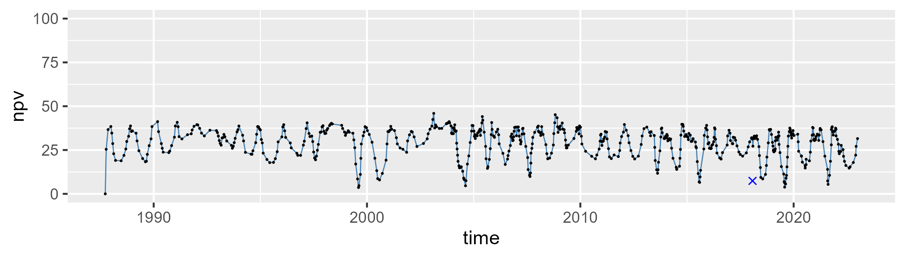

| Min. | 1st Qu. | Median | Mean | 3rd Qu. | Max. |
| --- | --- | --- | --- | --- | --- |
| 0 | 1.424954 | 3.732837 | 4.771734 | 6.958279 | 23.74398 |

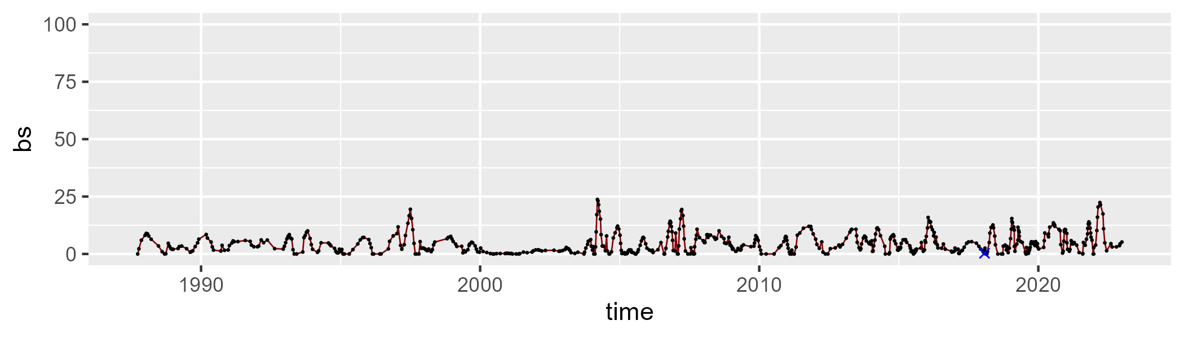

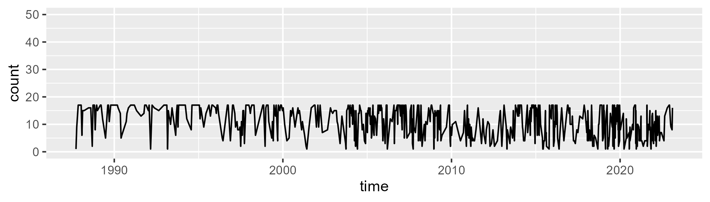

Min. : 1.00 1st Qu.: 6.00 Median :13.00 Mean :11.13 3rd Qu.:17.00 Max. :17.00

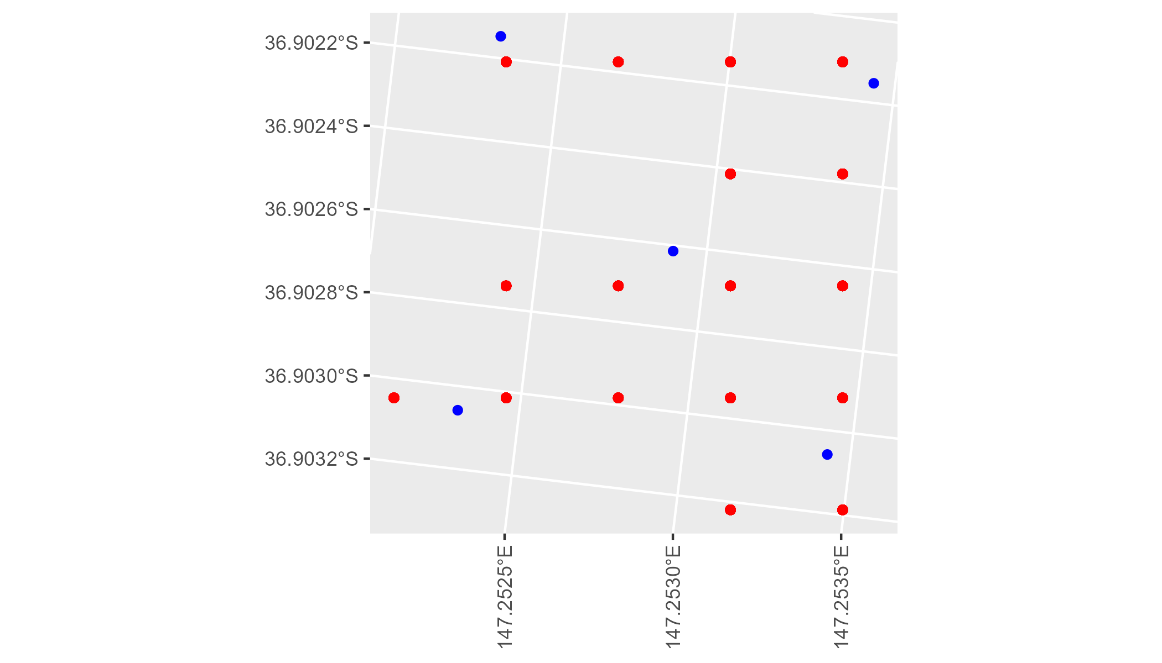

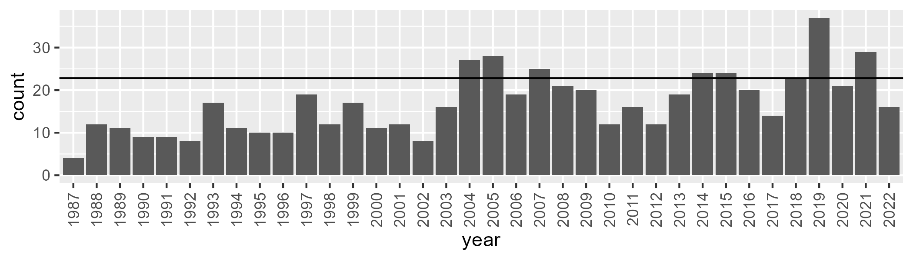

Number of samples: 603

# VCAAUA0009

| Min. | 1st Qu. | Median | Mean | 3rd Qu. | Max. |
| --- | --- | --- | --- | --- | --- |
| 12.01301 | 58.77253 | 63.53061 | 64.39435 | 70.12336 | 109.278 |

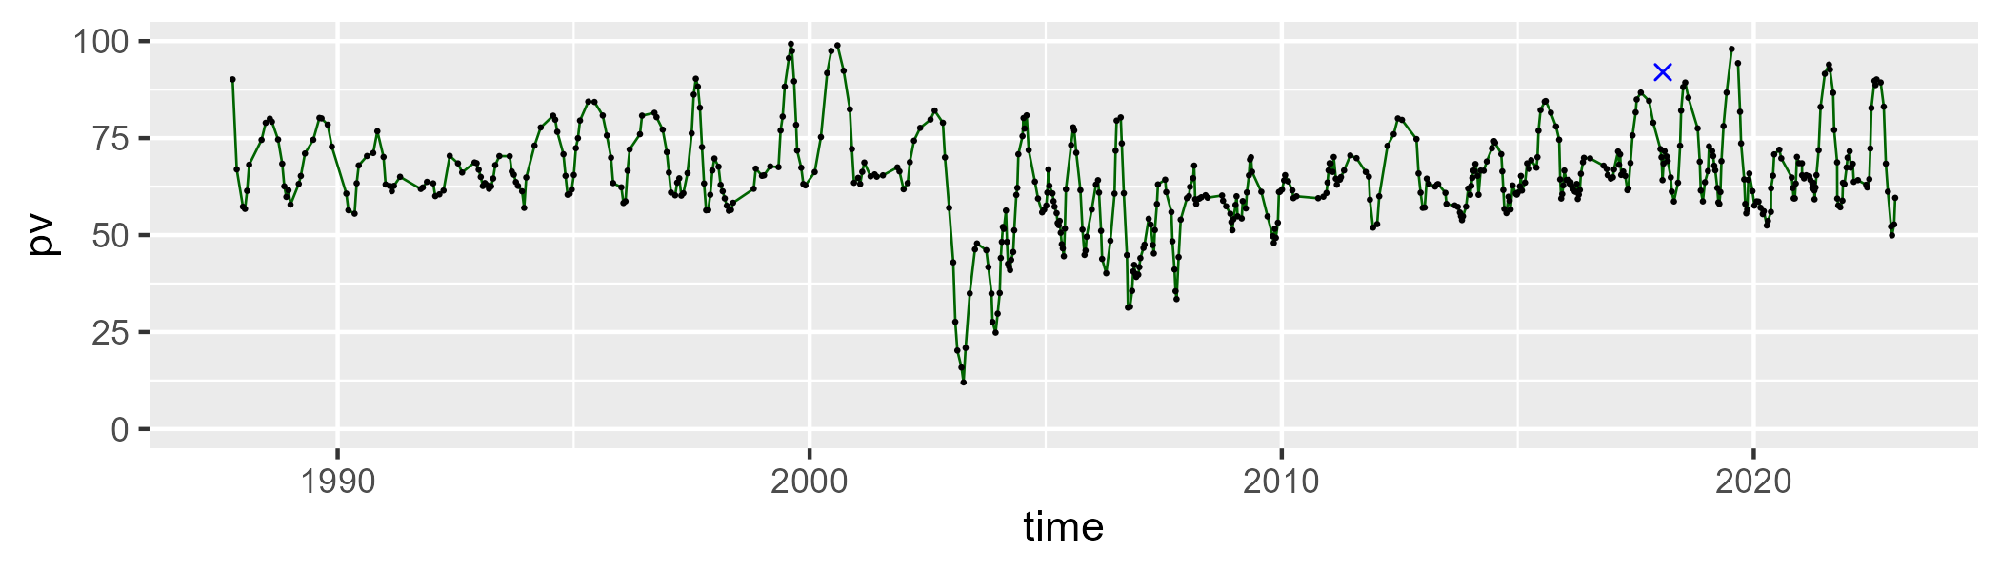

| Min. | 1st Qu. | Median | Mean | 3rd Qu. | Max. |
| --- | --- | --- | --- | --- | --- |
| 0 | 27.00113 | 31.89043 | 31.69125 | 36.68042 | 61.16427 |

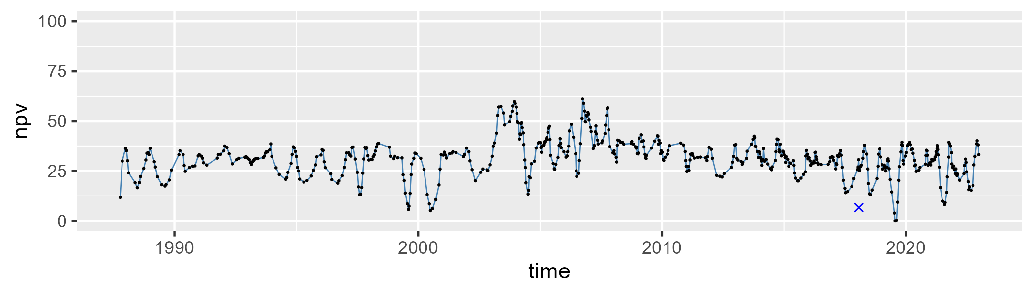

| Min. | 1st Qu. | Median | Mean | 3rd Qu. | Max. |
| --- | --- | --- | --- | --- | --- |
| 0 | 1.241893 | 2.769716 | 3.892036 | 5.531305 | 39.57737 |

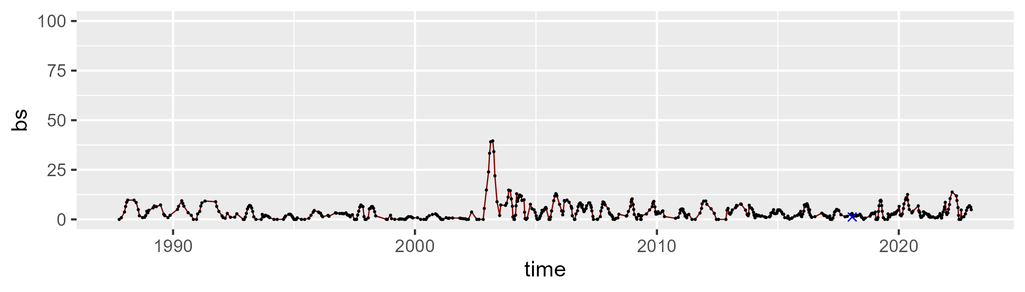

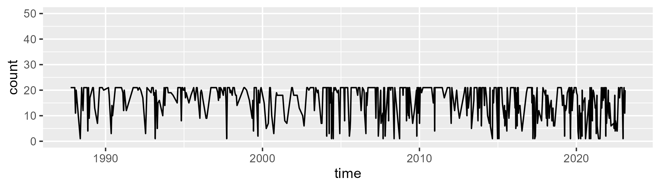

Min. : 1.00 1st Qu.:13.00 Median :20.00 Mean :16.34 3rd Qu.:21.00 Max. :21.00

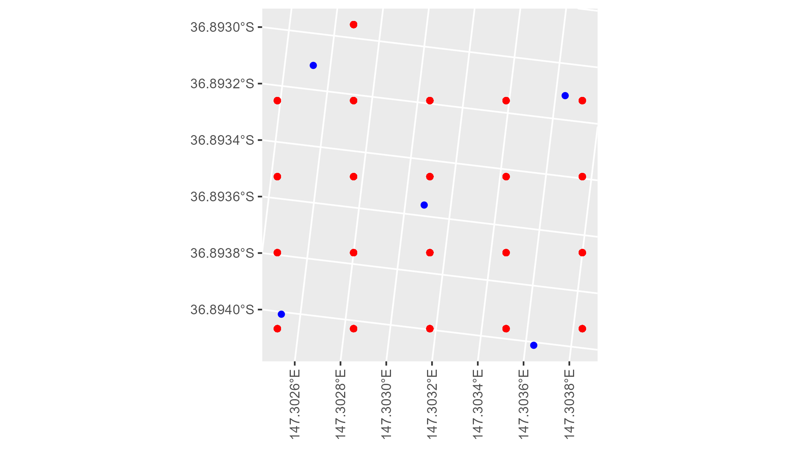

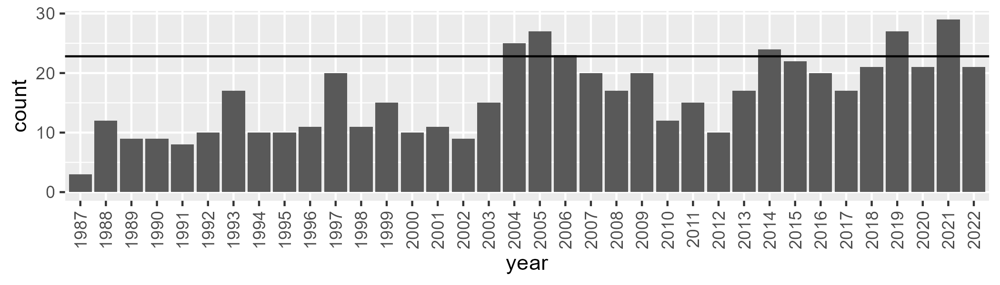

Number of samples: 578

# VCAAUA0010

| Min. | 1st Qu. | Median | Mean | 3rd Qu. | Max. |
| --- | --- | --- | --- | --- | --- |
| 17.69349 | 51.8738 | 58.93146 | 59.78036 | 66.41621 | 106.2533 |

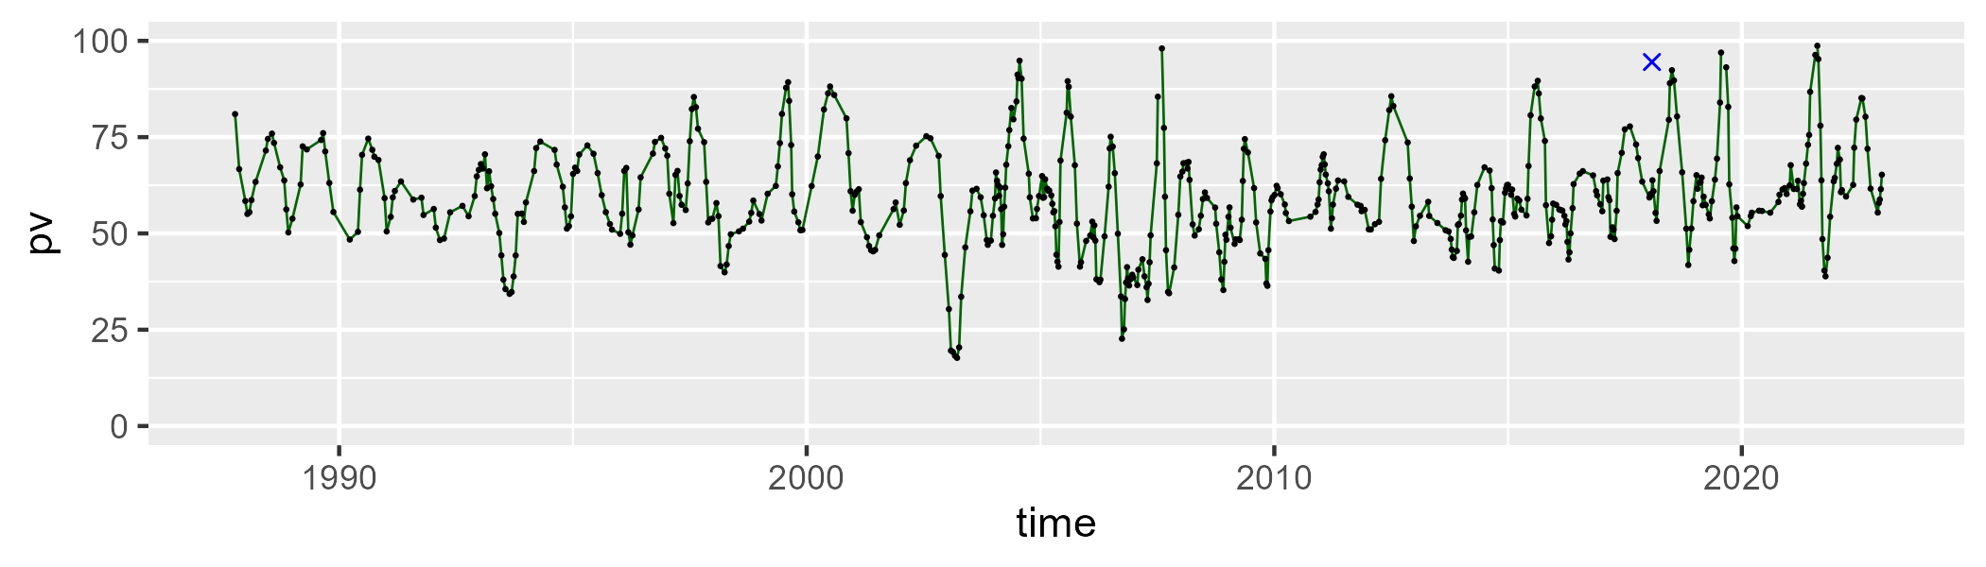

| Min. | 1st Qu. | Median | Mean | 3rd Qu. | Max. |
| --- | --- | --- | --- | --- | --- |
| 0 | 28.57014 | 35.87079 | 35.4822 | 42.92137 | 73.73013 |

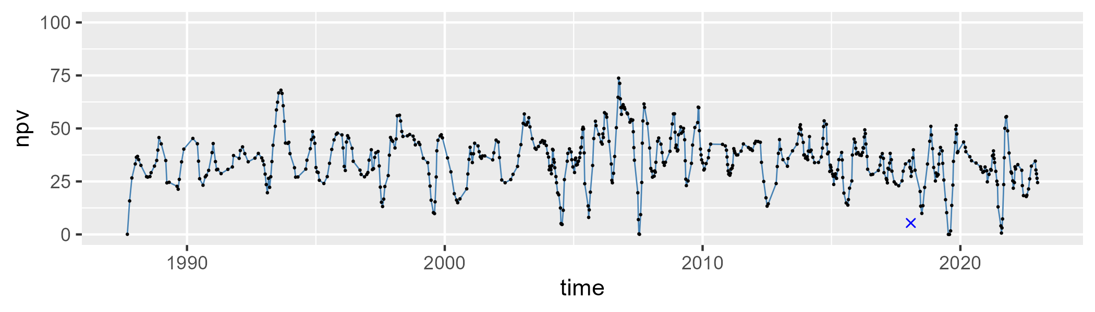

| Min. | 1st Qu. | Median | Mean | 3rd Qu. | Max. |
| --- | --- | --- | --- | --- | --- |
| 0 | 1.549775 | 3.30427 | 4.336857 | 5.84 | 29.47332 |

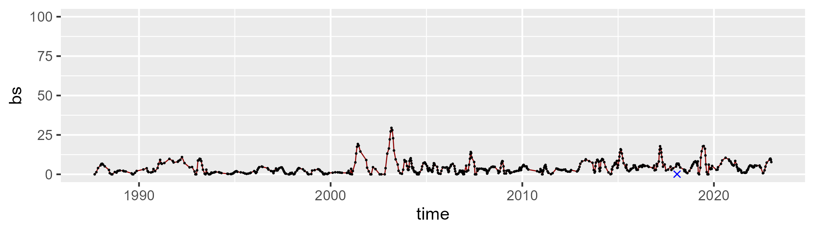

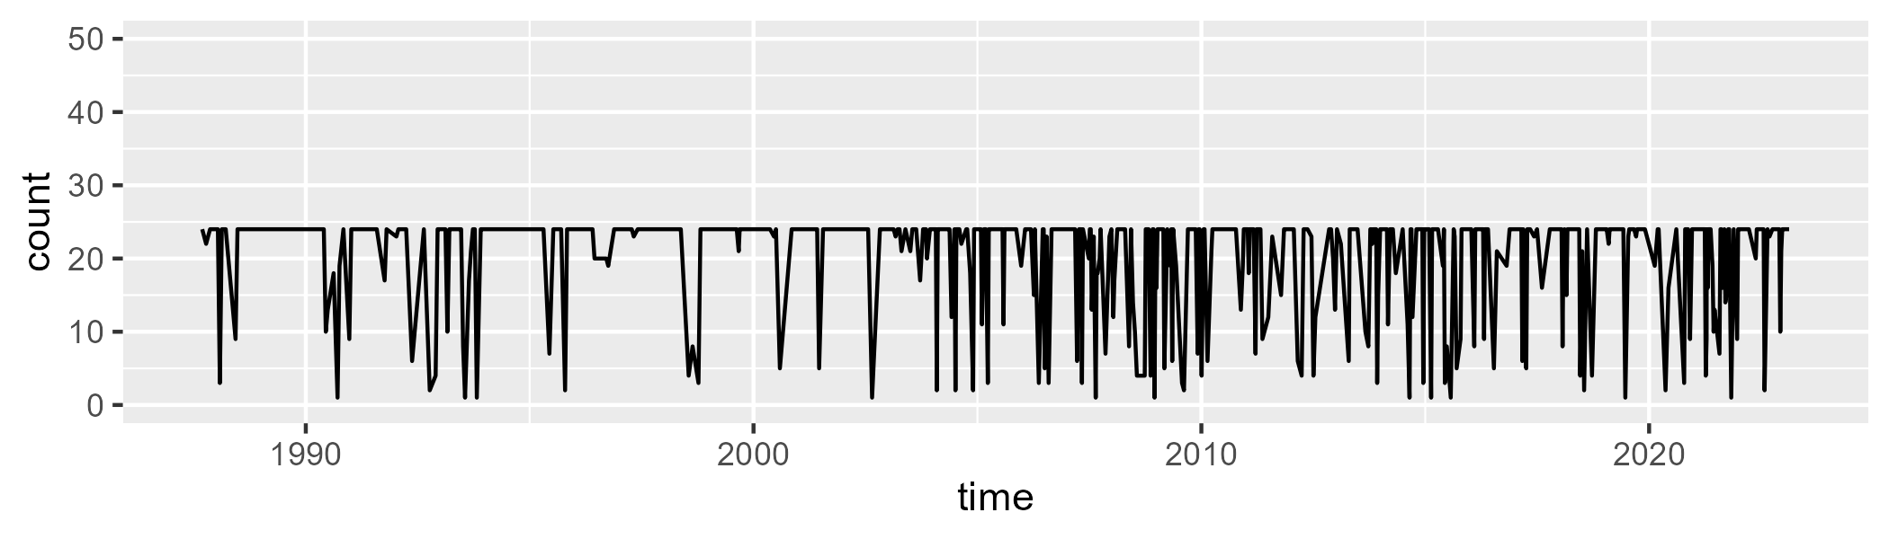

Min. : 1.00 1st Qu.:22.00 Median :24.00 Mean :20.57 3rd Qu.:24.00 Max. :24.00

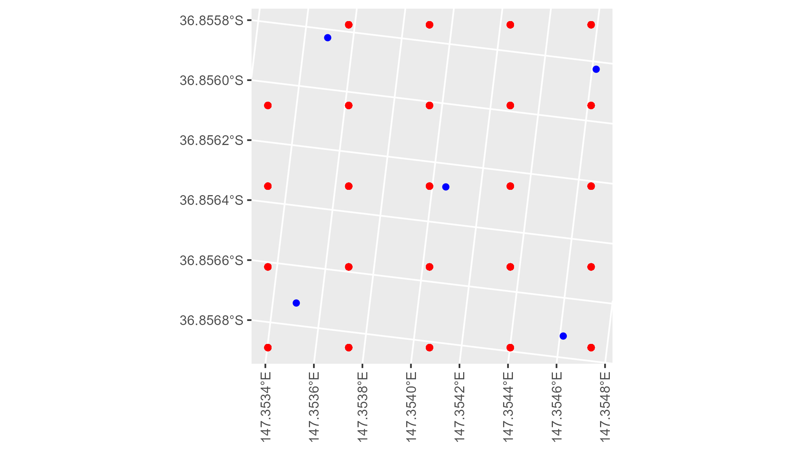

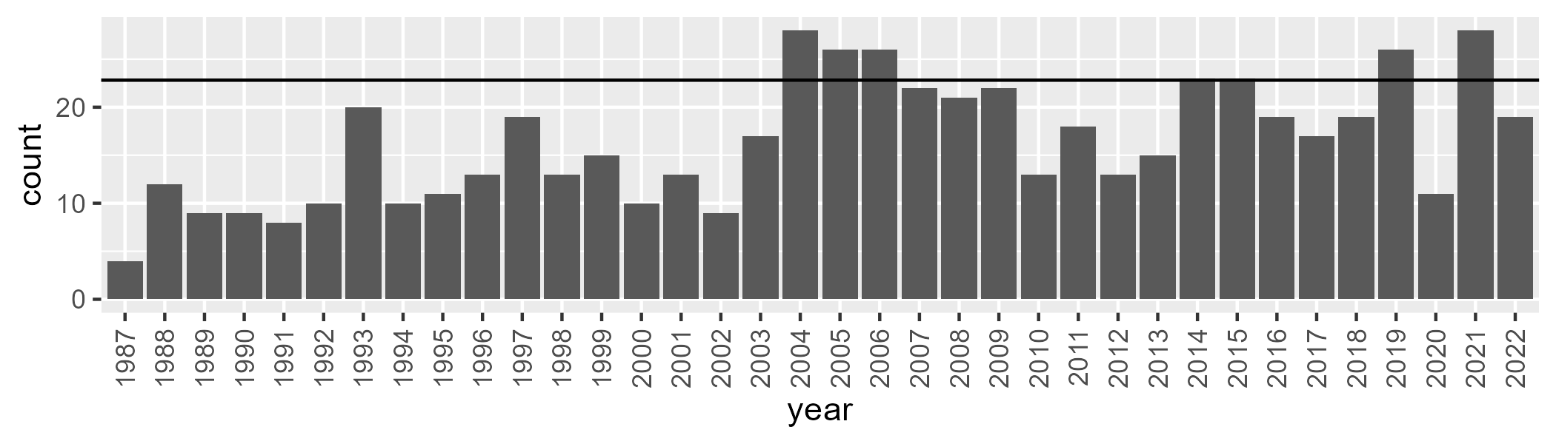

Number of samples: 591

# VCAAUA0011

| Min. | 1st Qu. | Median | Mean | 3rd Qu. | Max. |
| --- | --- | --- | --- | --- | --- |
| 29.985 | 48.46125 | 57.60262 | 57.16121 | 64.84185 | 108.9714 |

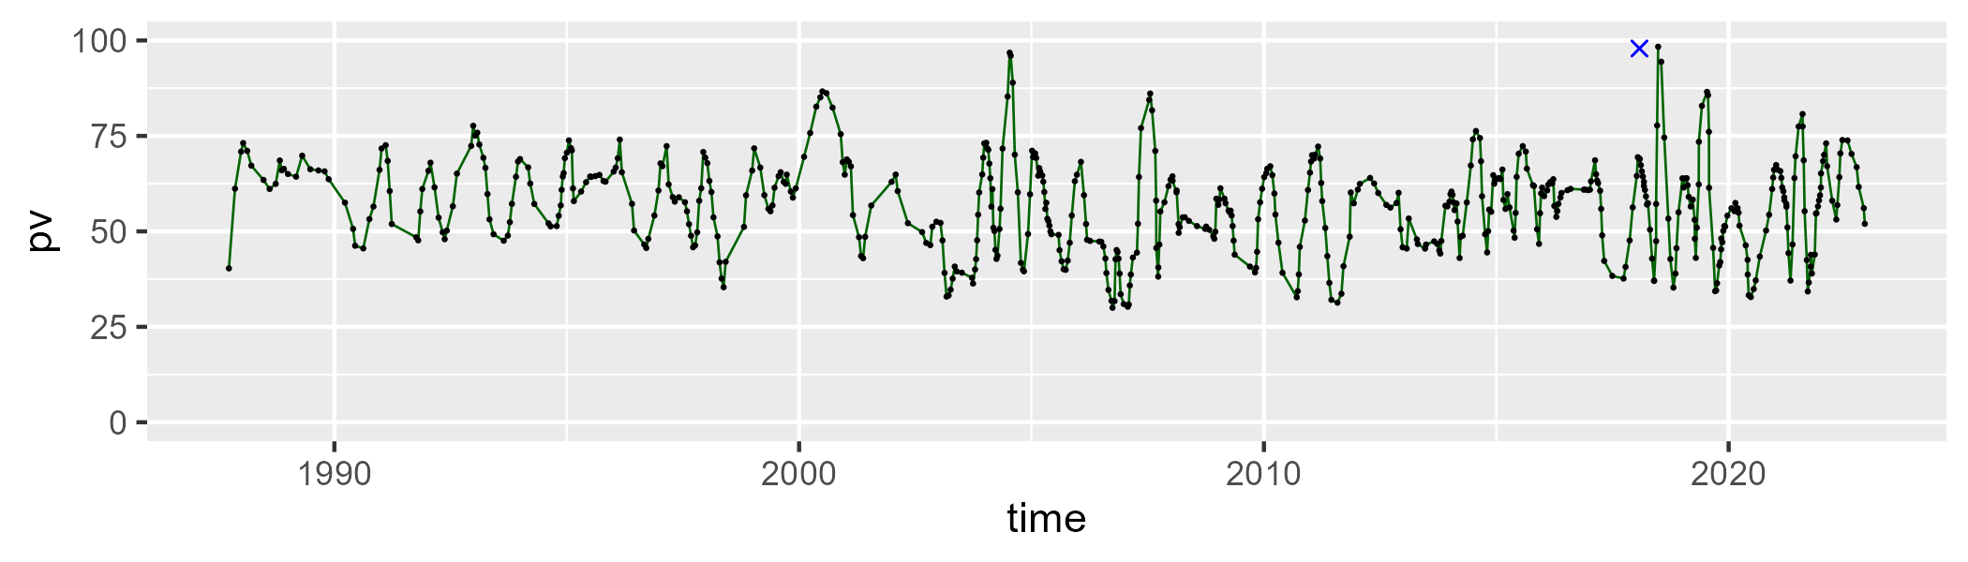

| Min. | 1st Qu. | Median | Mean | 3rd Qu. | Max. |
| --- | --- | --- | --- | --- | --- |
| 0 | 28.88834 | 35.43891 | 35.93584 | 42.80352 | 66.06374 |

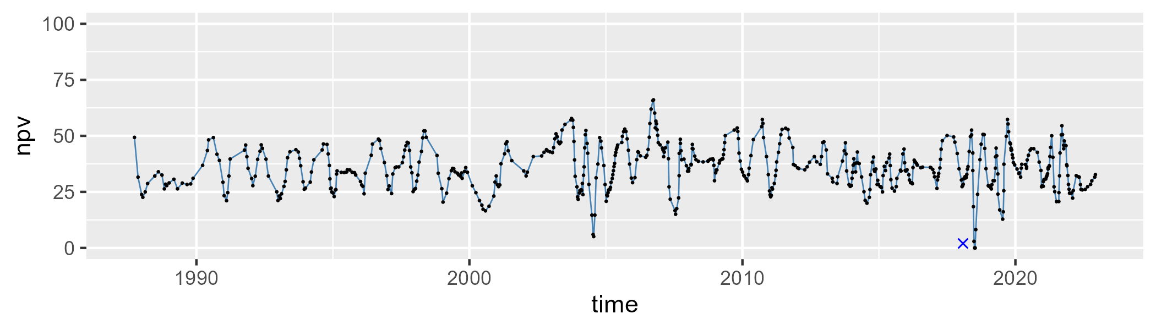

| Min. | 1st Qu. | Median | Mean | 3rd Qu. | Max. |
| --- | --- | --- | --- | --- | --- |
| 0 | 3.011525 | 5.169257 | 5.999703 | 7.982603 | 26.23858 |

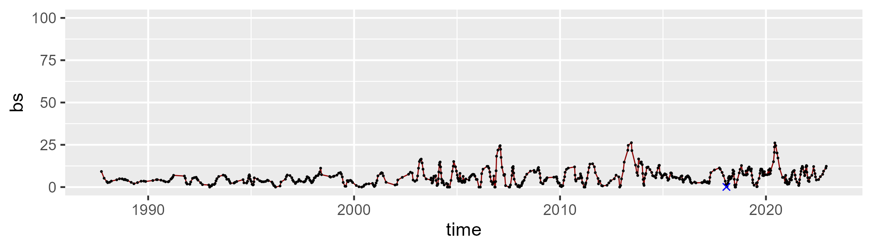

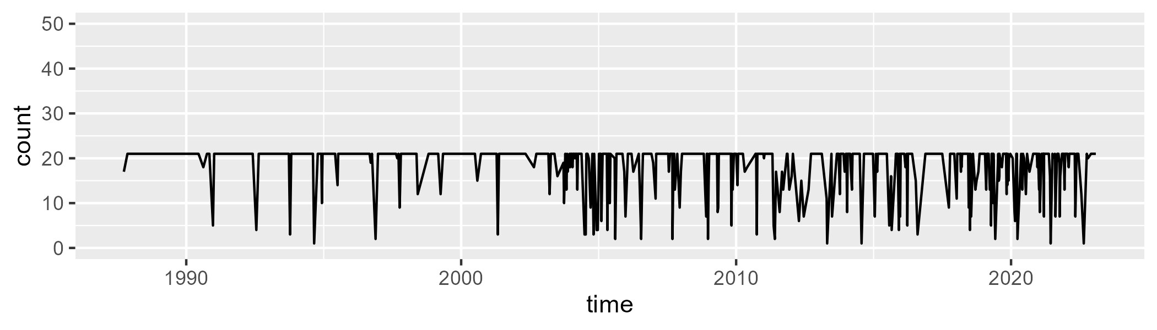

Min. : 1.00 1st Qu.:21.00 Median :21.00 Mean :18.64 3rd Qu.:21.00 Max. :21.00

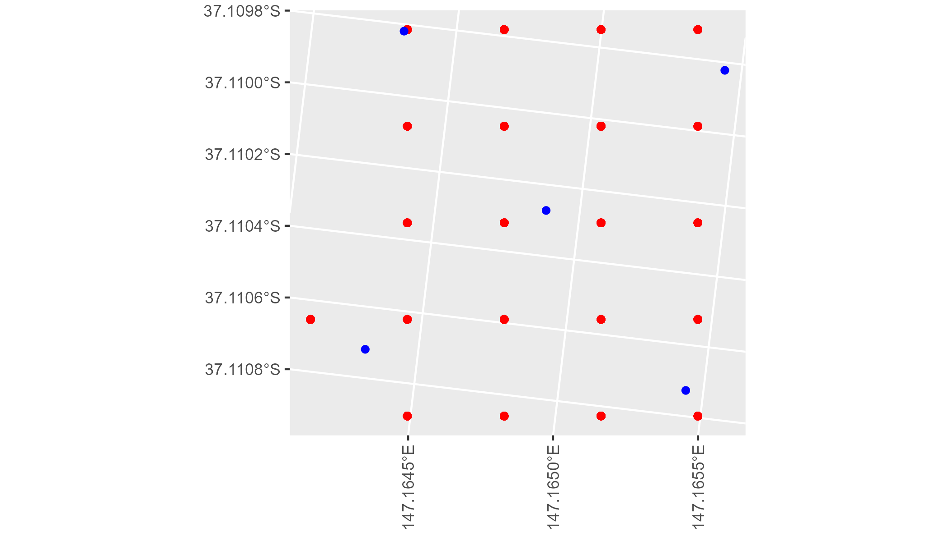

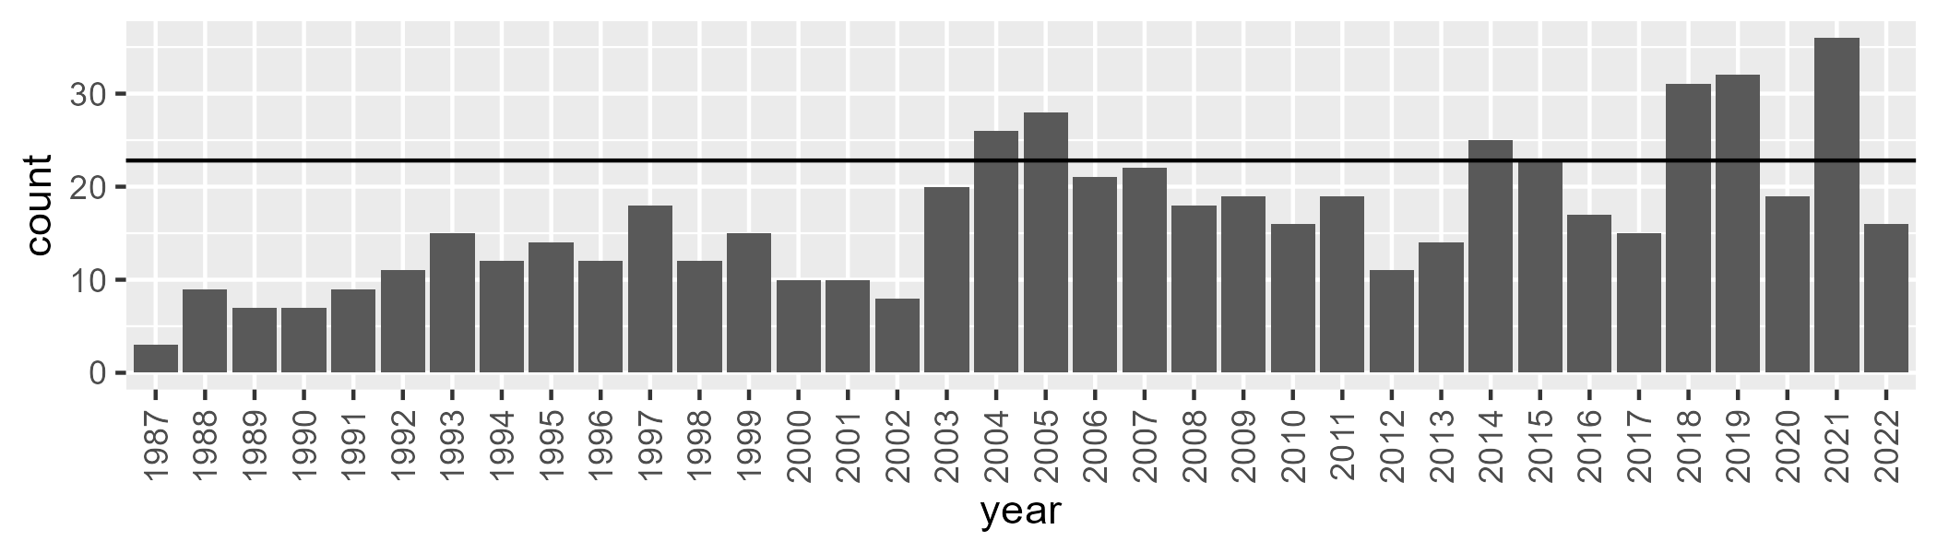

Number of samples: 600

# VCAAUA0012

| Min. | 1st Qu. | Median | Mean | 3rd Qu. | Max. |
| --- | --- | --- | --- | --- | --- |
| 25.62625 | 48.91715 | 57.60615 | 57.0829 | 63.99745 | 107.2092 |

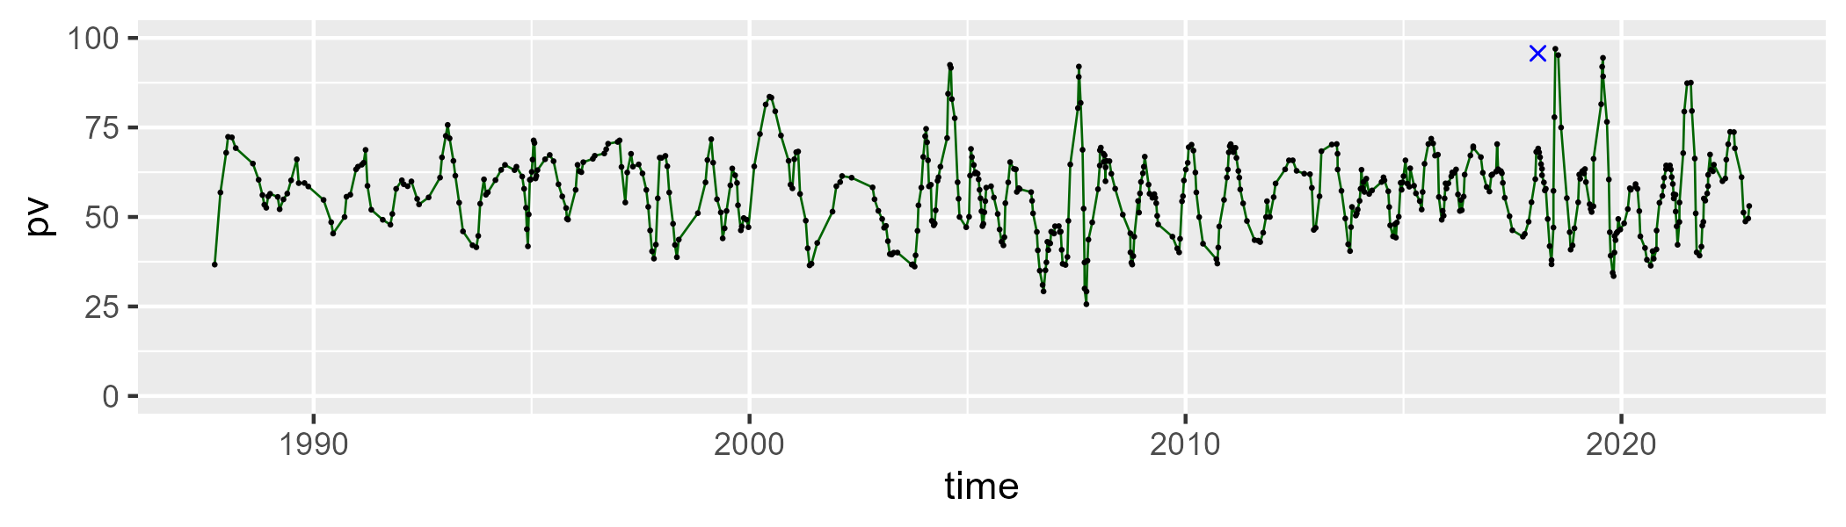

| Min. | 1st Qu. | Median | Mean | 3rd Qu. | Max. |
| --- | --- | --- | --- | --- | --- |
| 0 | 30.36701 | 35.15977 | 35.88808 | 41.87349 | 64.55147 |

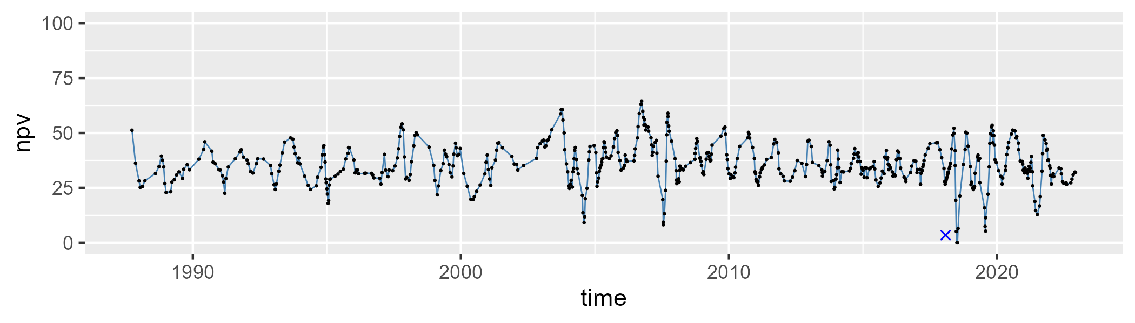

| Min. | 1st Qu. | Median | Mean | 3rd Qu. | Max. |
| --- | --- | --- | --- | --- | --- |
| 0 | 2.721064 | 5.154208 | 6.124995 | 8.790633 | 23.23939 |

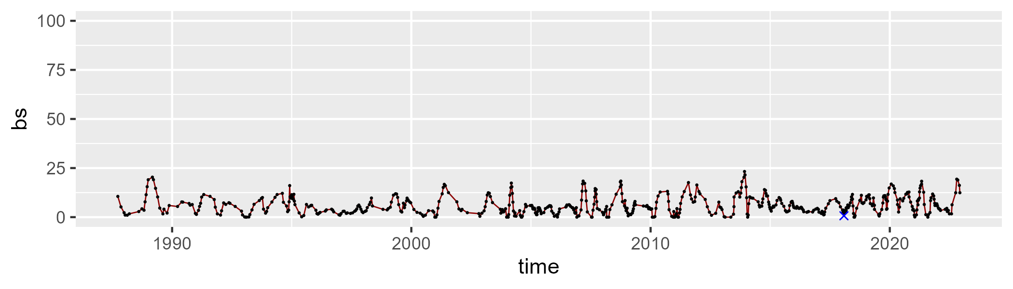

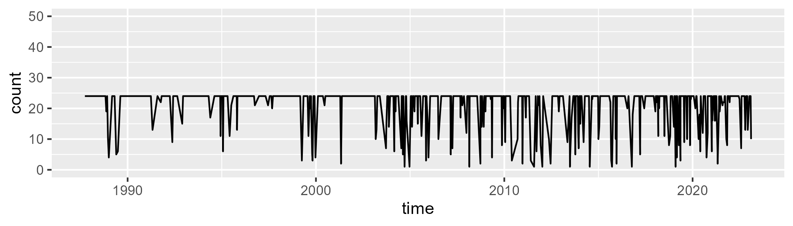

Min. : 1.00 1st Qu.:24.00 Median :24.00 Mean :20.91 3rd Qu.:24.00 Max. :24.00

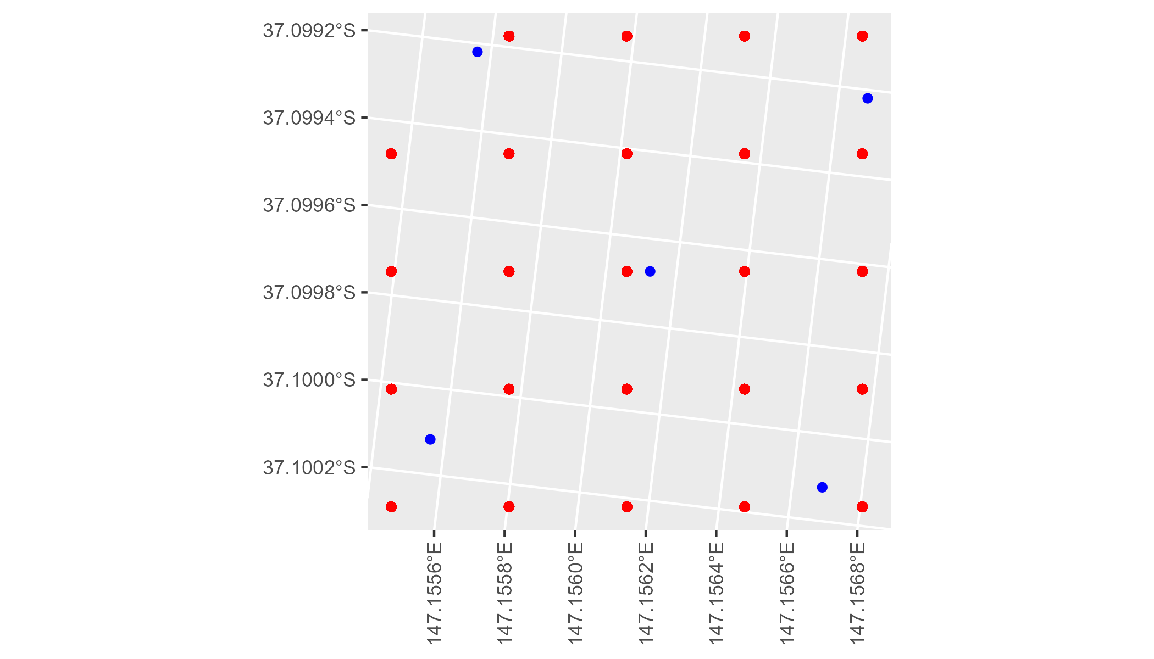

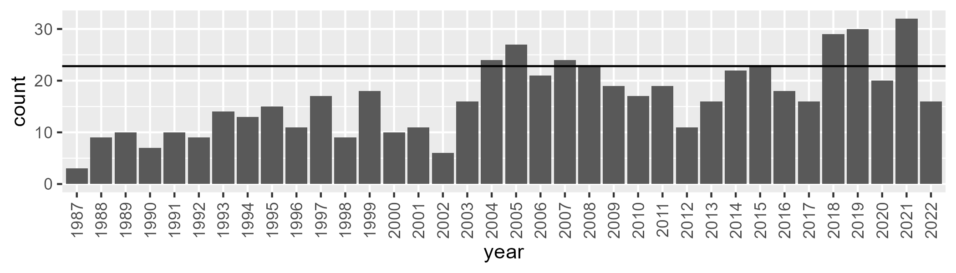

Number of samples: 595

# VCAAUA0013

| Min. | 1st Qu. | Median | Mean | 3rd Qu. | Max. |
| --- | --- | --- | --- | --- | --- |
| 12.04754 | 45.02645 | 52.96963 | 52.22993 | 58.96806 | 97.89131 |

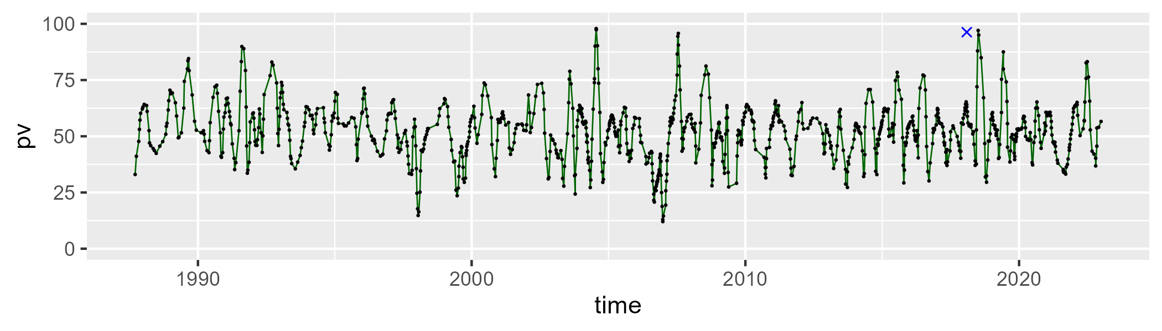

| Min. | 1st Qu. | Median | Mean | 3rd Qu. | Max. |
| --- | --- | --- | --- | --- | --- |
| 6.233762 | 35.2561 | 40.74564 | 41.28088 | 47.12104 | 72.94529 |

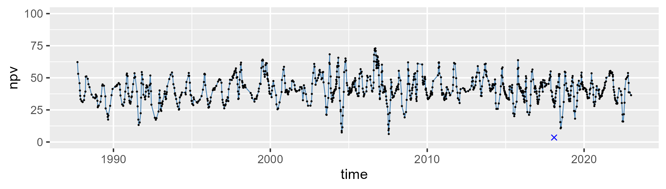

| Min. | 1st Qu. | Median | Mean | 3rd Qu. | Max. |
| --- | --- | --- | --- | --- | --- |
| 0 | 2.552105 | 4.560806 | 5.824128 | 7.647058 | 52.79167 |

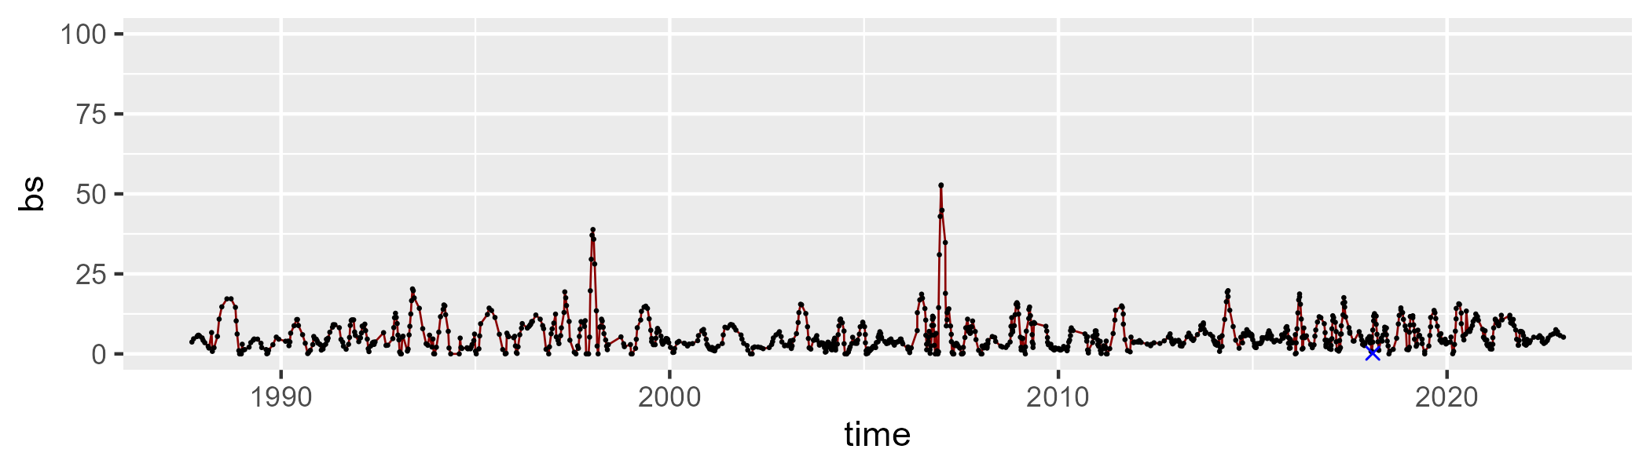

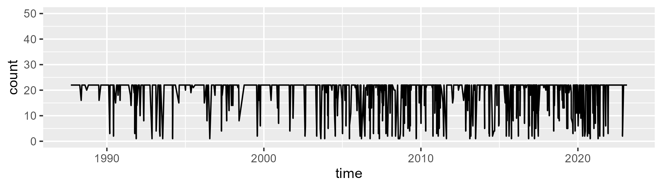

Min. : 1.00 1st Qu.:21.00 Median :22.00 Mean :19.15 3rd Qu.:22.00 Max. :22.00

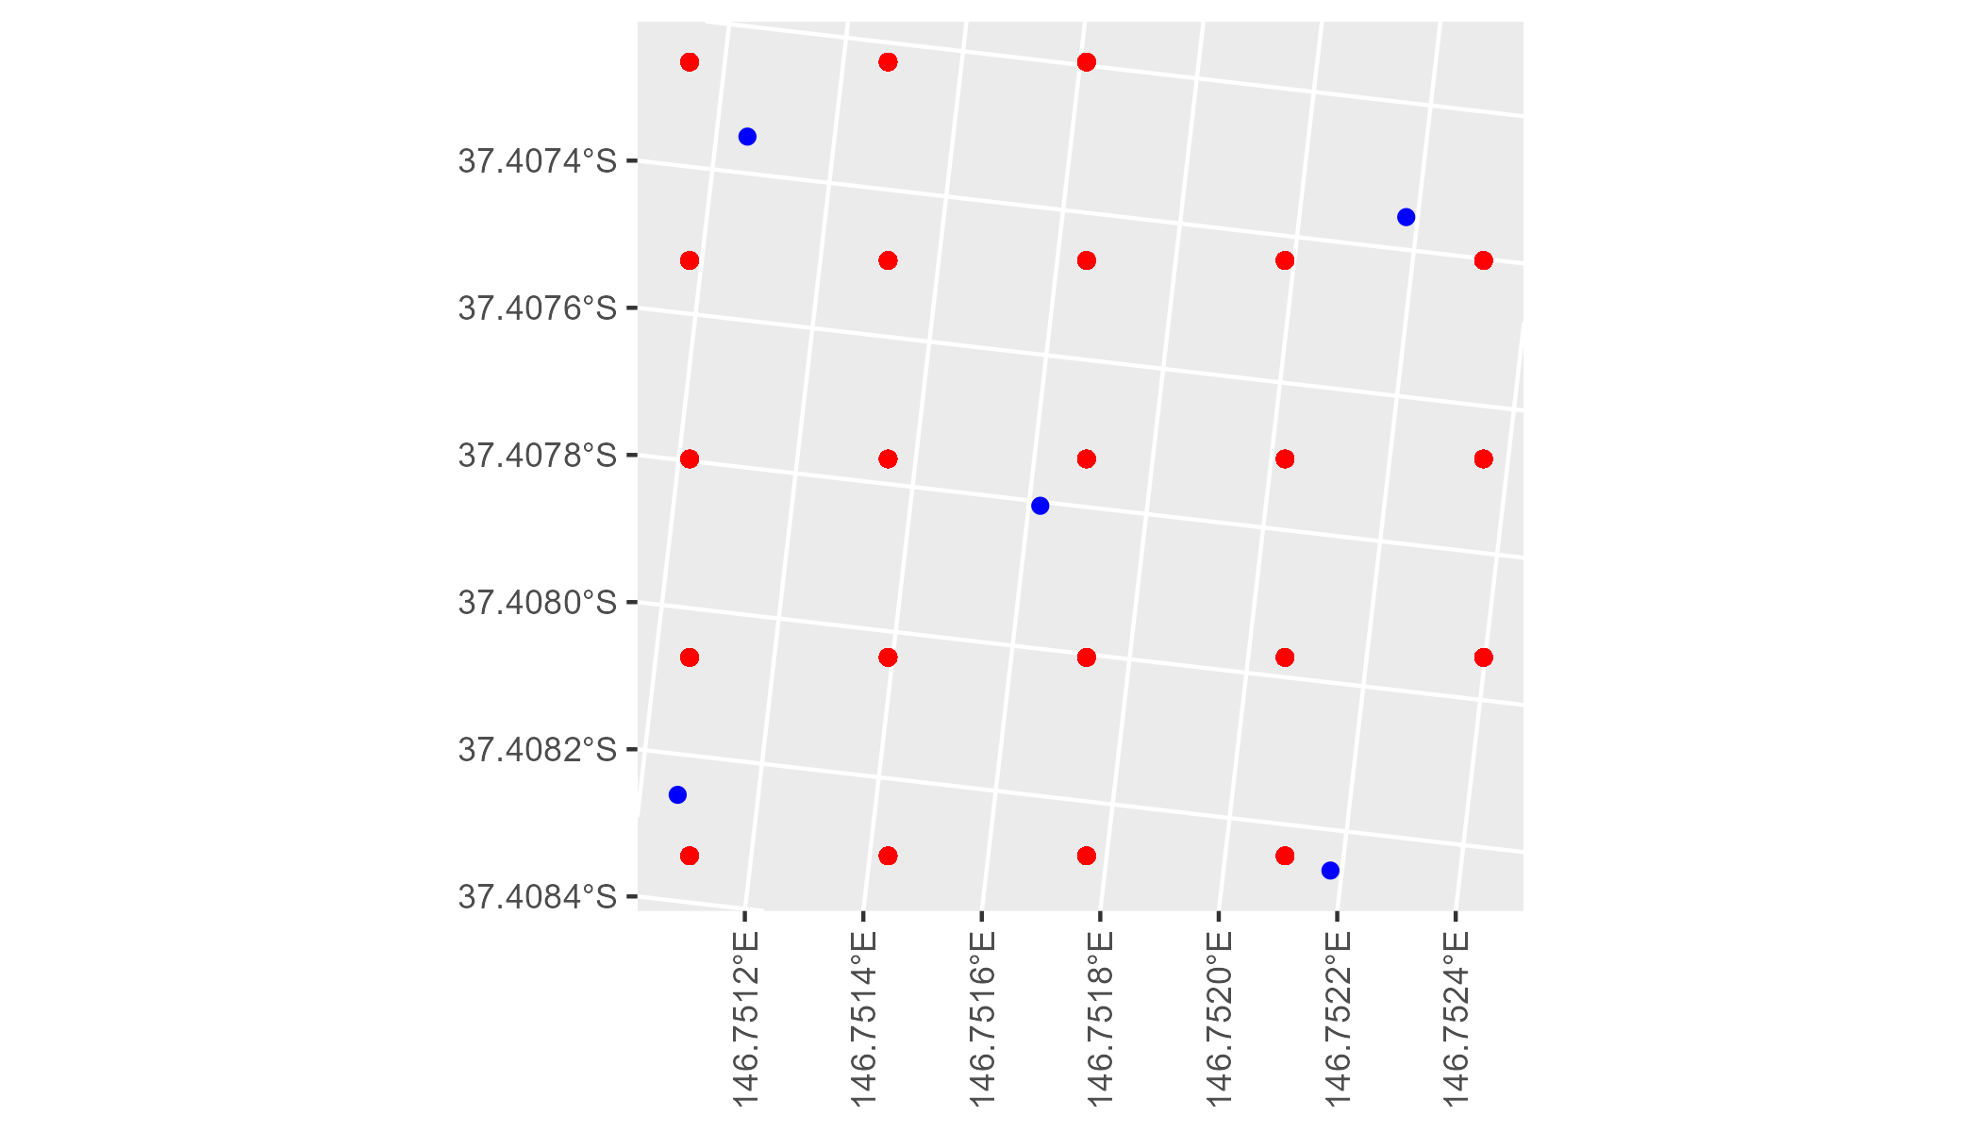

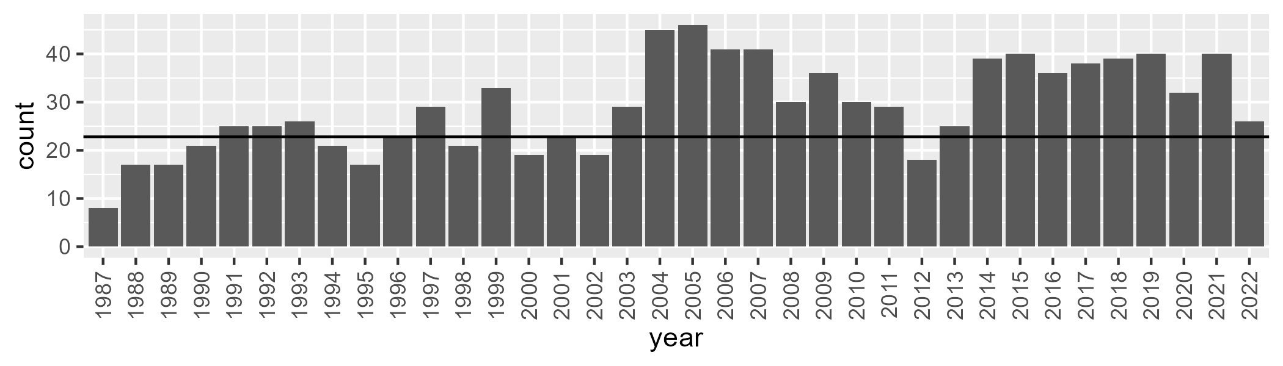

Number of samples: 1044

# VCAAUA0014

| Min. | 1st Qu. | Median | Mean | 3rd Qu. | Max. |
| --- | --- | --- | --- | --- | --- |
| 1.964046 | 44.13309 | 51.09501 | 51.50747 | 58.24498 | 108.9457 |

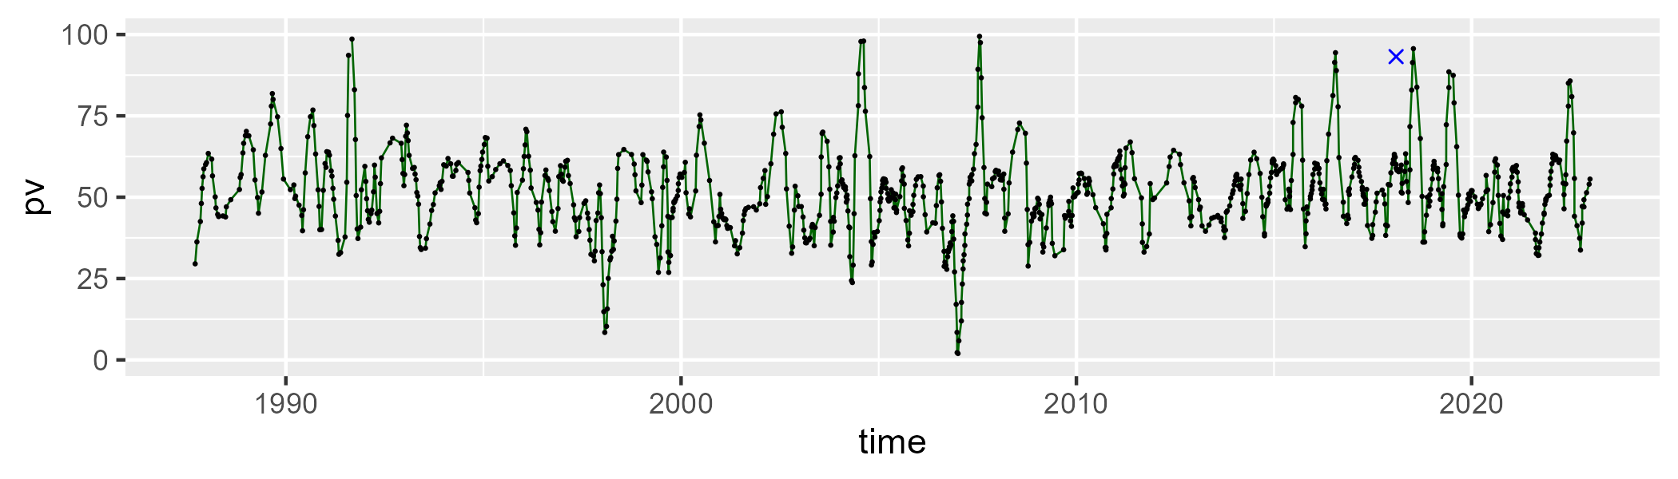

| Min. | 1st Qu. | Median | Mean | 3rd Qu. | Max. |
| --- | --- | --- | --- | --- | --- |
| 0 | 36.59308 | 42.50702 | 42.11146 | 48.55026 | 68.5241 |

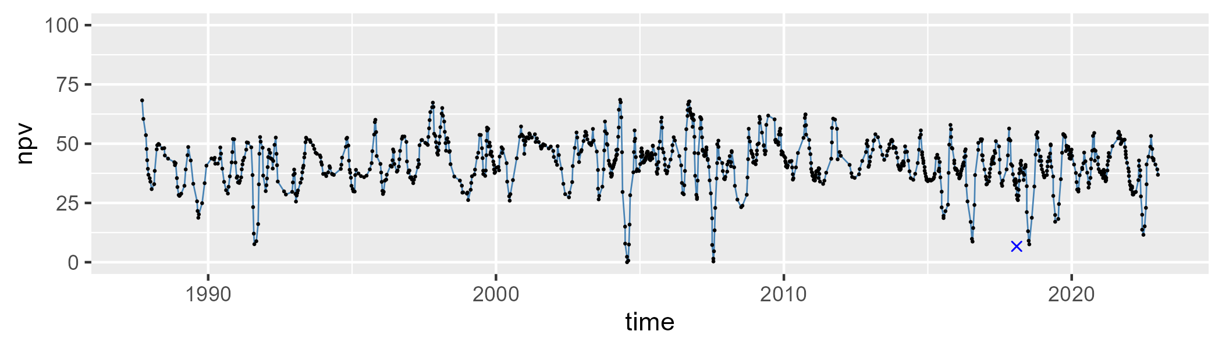

| Min. | 1st Qu. | Median | Mean | 3rd Qu. | Max. |
| --- | --- | --- | --- | --- | --- |
| 0 | 2.615979 | 4.458937 | 5.85142 | 7.329432 | 69.34629 |

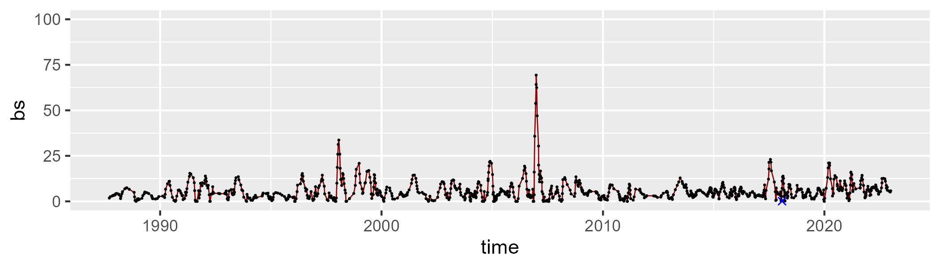

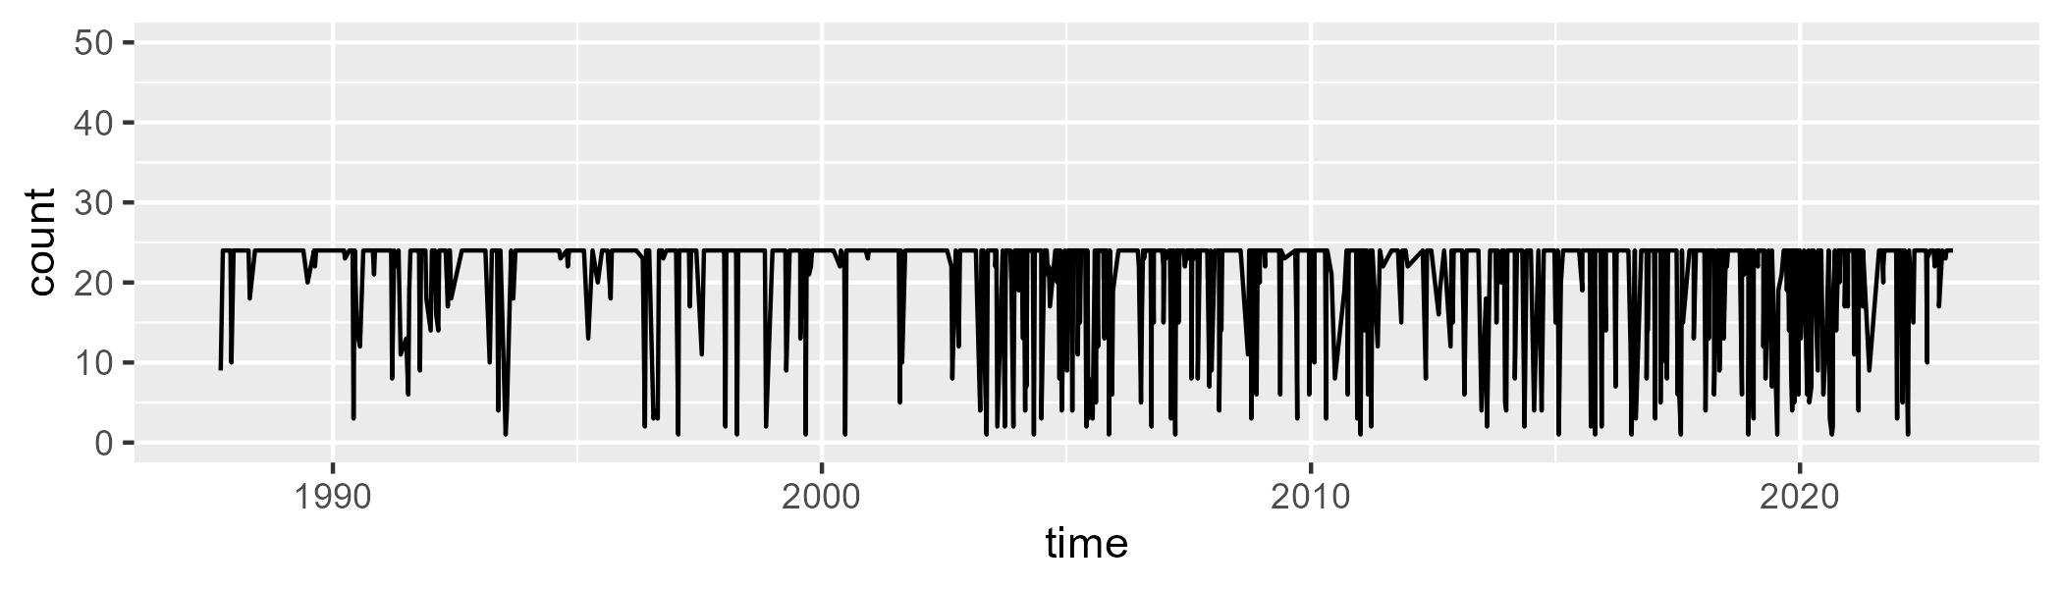

Min. : 1.00 1st Qu.:24.00 Median :24.00 Mean :20.96 3rd Qu.:24.00 Max. :24.00

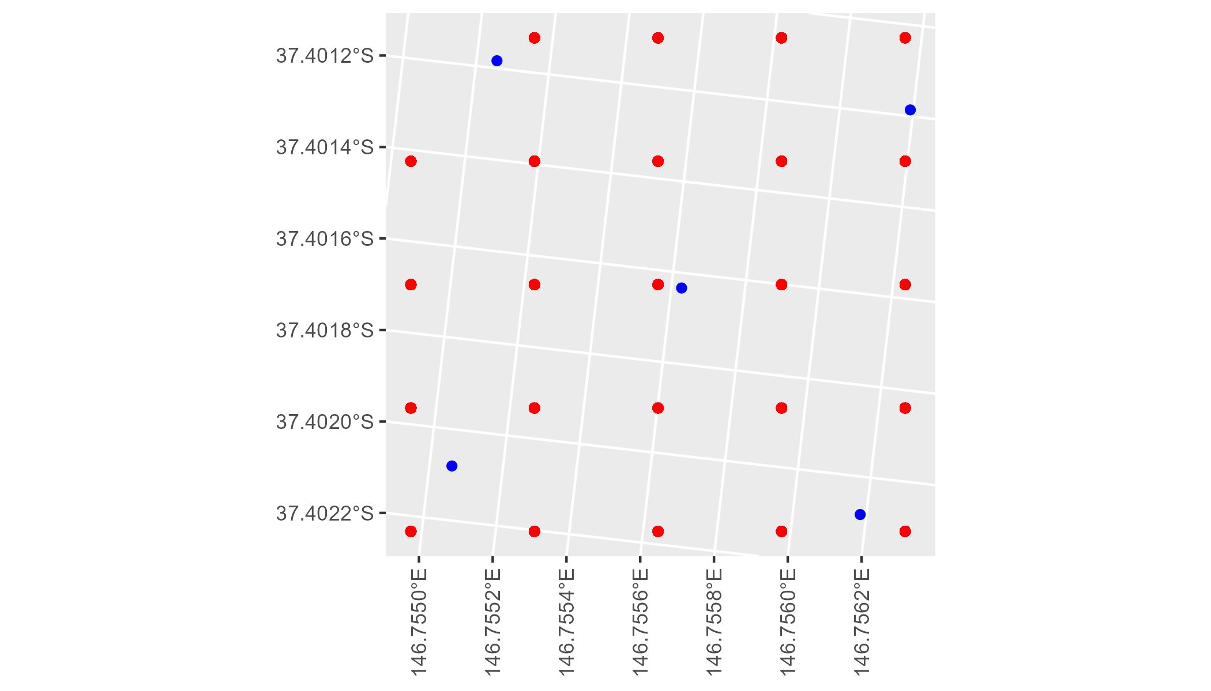

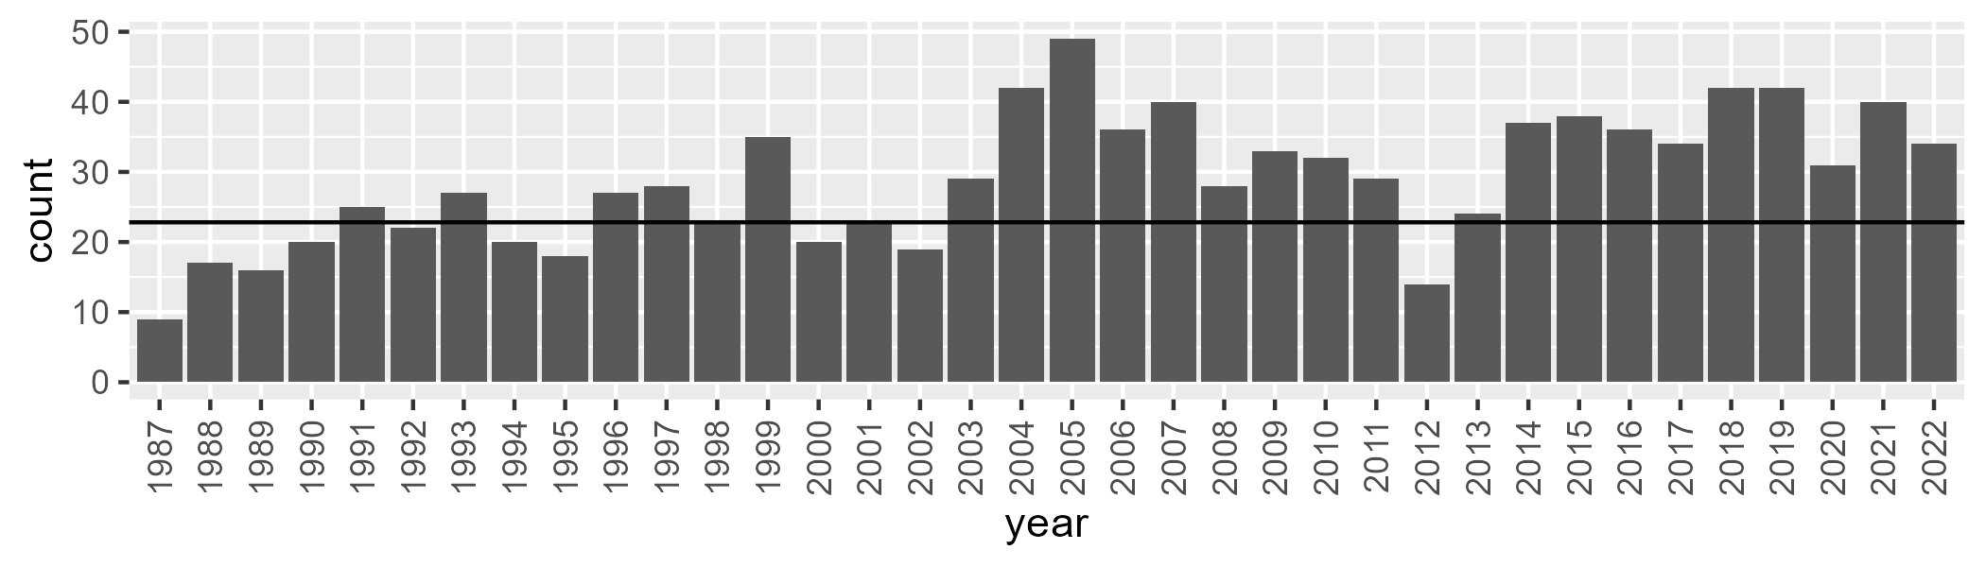

Number of samples: 1039

# VCAAUA0015

| Min. | 1st Qu. | Median | Mean | 3rd Qu. | Max. |
| --- | --- | --- | --- | --- | --- |
| 7.566739 | 47.2576 | 53.87081 | 53.5969 | 59.18408 | 96.6006 |

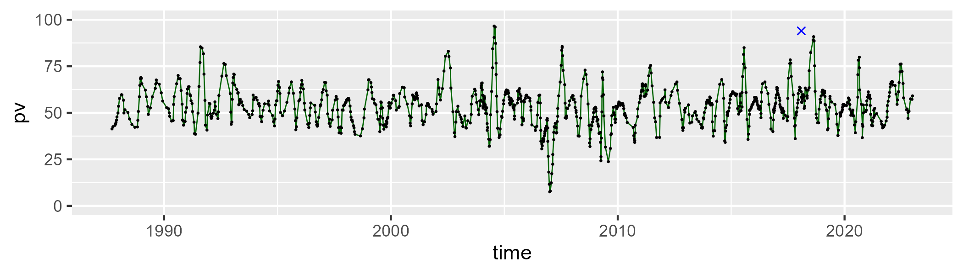

| Min. | 1st Qu. | Median | Mean | 3rd Qu. | Max. |
| --- | --- | --- | --- | --- | --- |
| 8.158861 | 34.77036 | 39.3948 | 39.51037 | 44.59174 | 63.66418 |

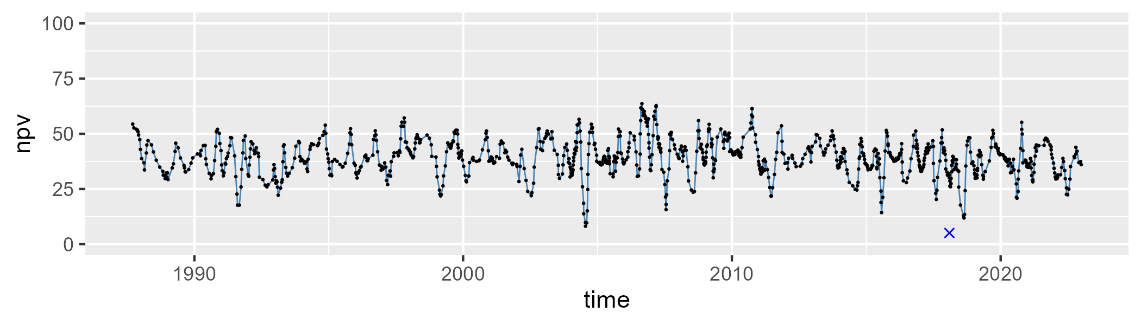

| Min. | 1st Qu. | Median | Mean | 3rd Qu. | Max. |
| --- | --- | --- | --- | --- | --- |
| 0 | 2.477223 | 4.403401 | 6.157316 | 8.124085 | 55.41613 |

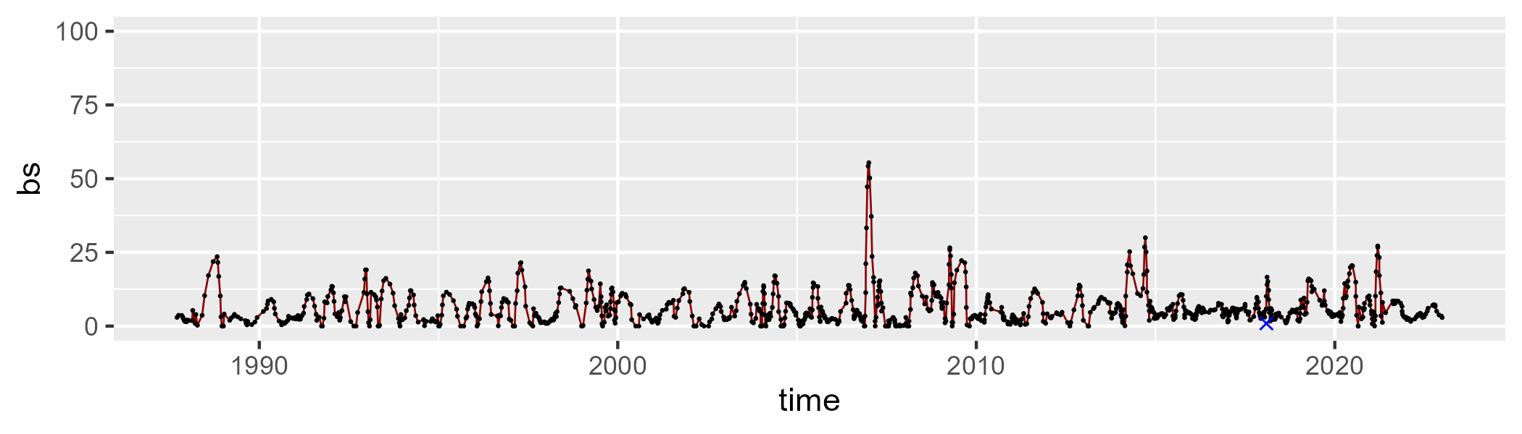

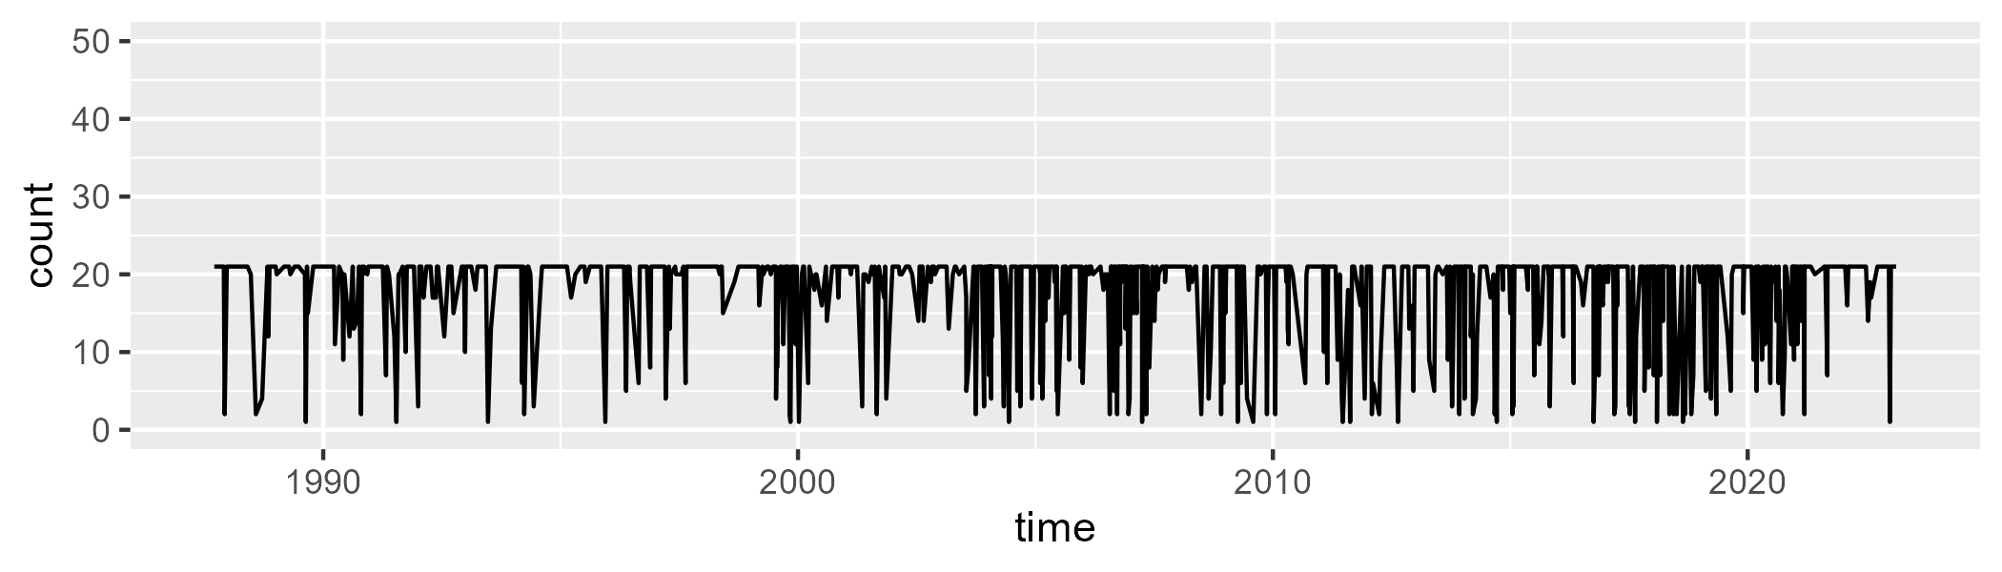

Min. : 1.00 1st Qu.:20.00 Median :21.00 Mean :18.14 3rd Qu.:21.00 Max. :21.00

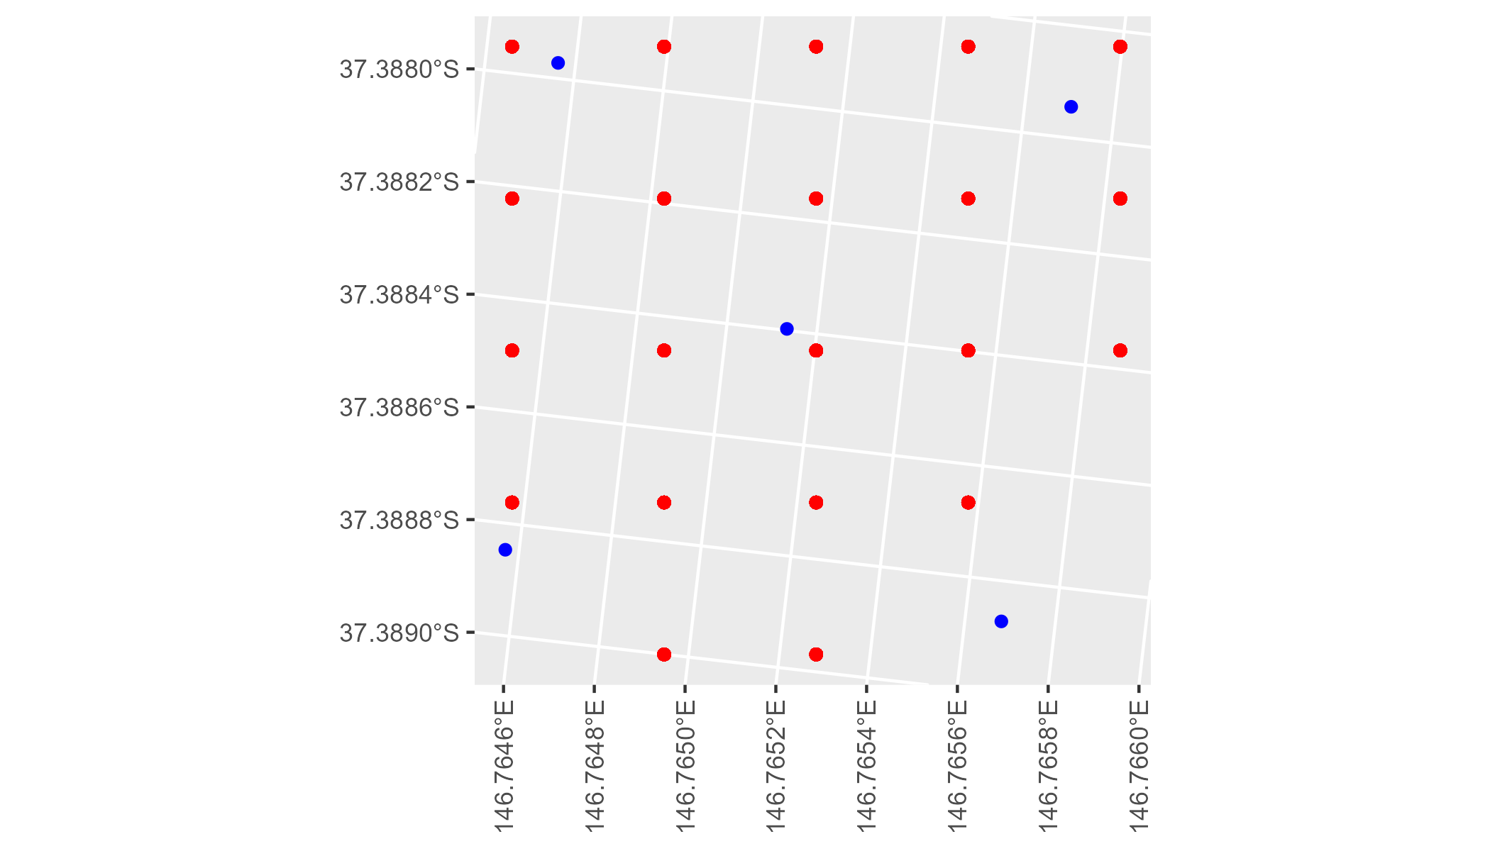

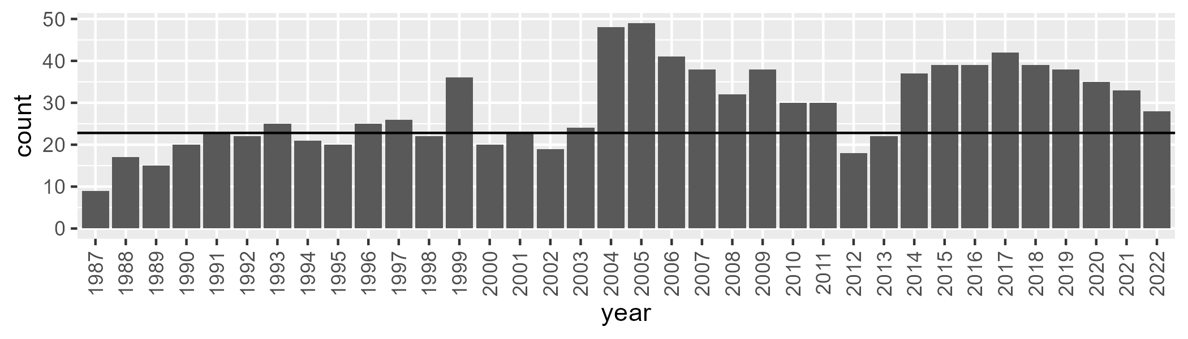

Number of samples: 1043

# VCAMDD0001

| Min. | 1st Qu. | Median | Mean | 3rd Qu. | Max. |
| --- | --- | --- | --- | --- | --- |
| 1.123543 | 8.211026 | 11.15287 | 12.32304 | 15.63102 | 33.184 |

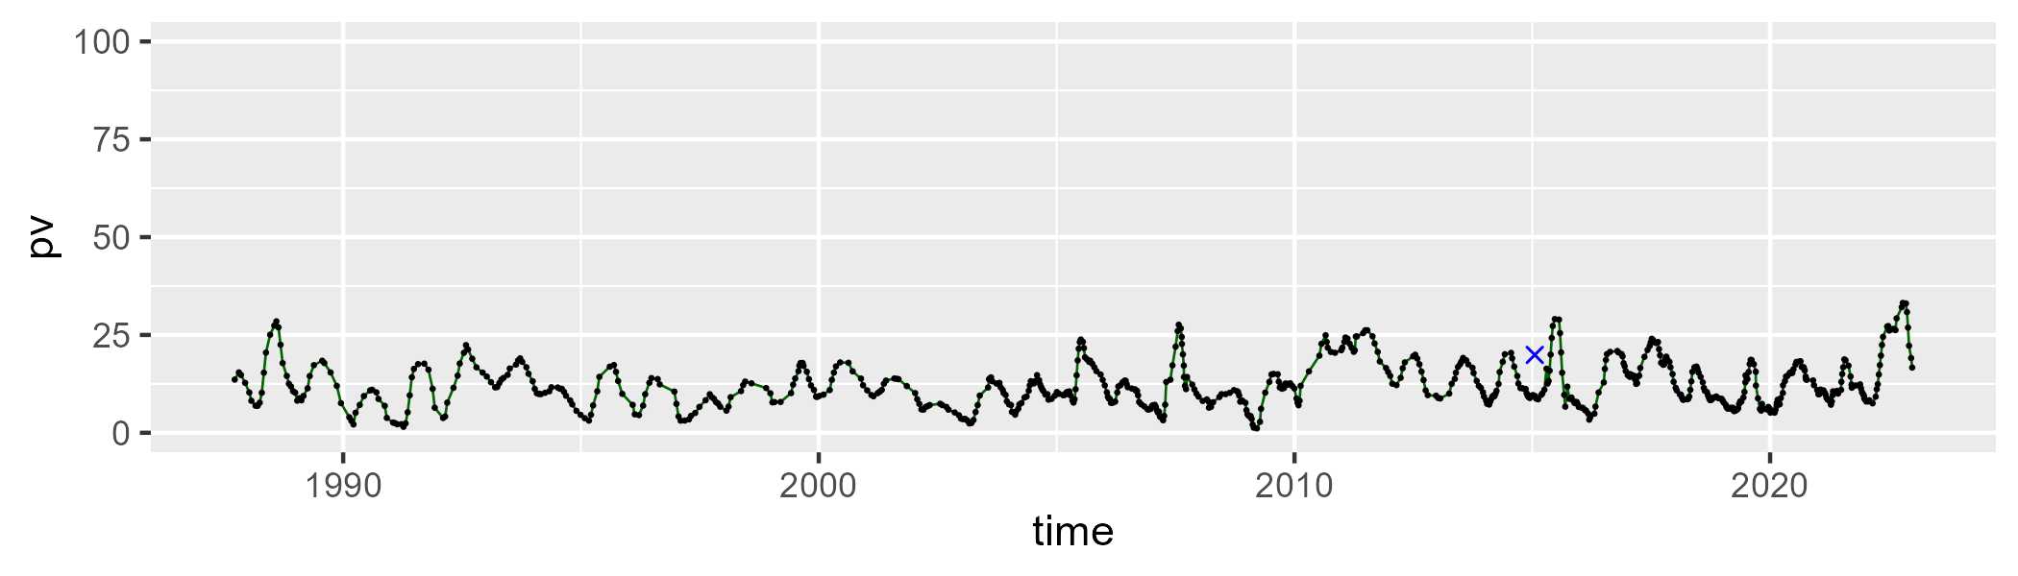

| Min. | 1st Qu. | Median | Mean | 3rd Qu. | Max. |
| --- | --- | --- | --- | --- | --- |
| 22.77879 | 33.59084 | 38.70162 | 39.20216 | 44.05472 | 61.49322 |

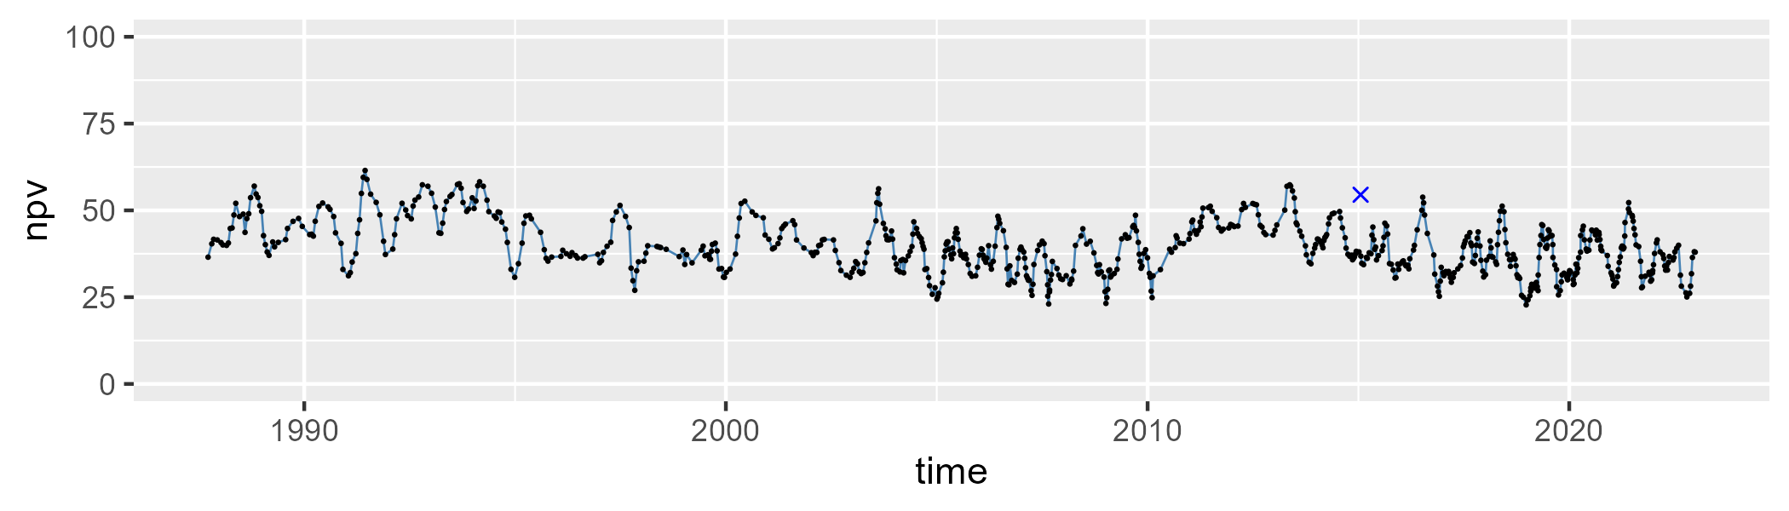

| Min. | 1st Qu. | Median | Mean | 3rd Qu. | Max. |
| --- | --- | --- | --- | --- | --- |
| 21.35093 | 39.21476 | 48.4402 | 47.19326 | 55.4316 | 70.87173 |

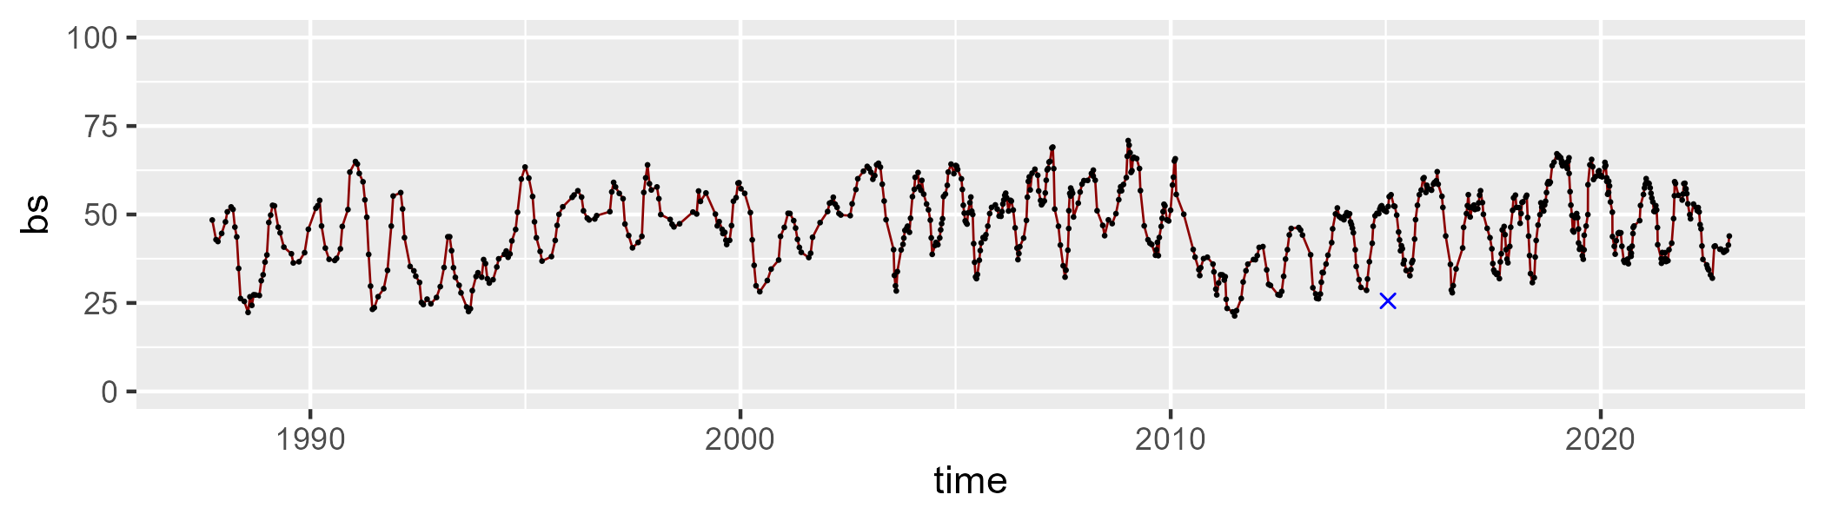

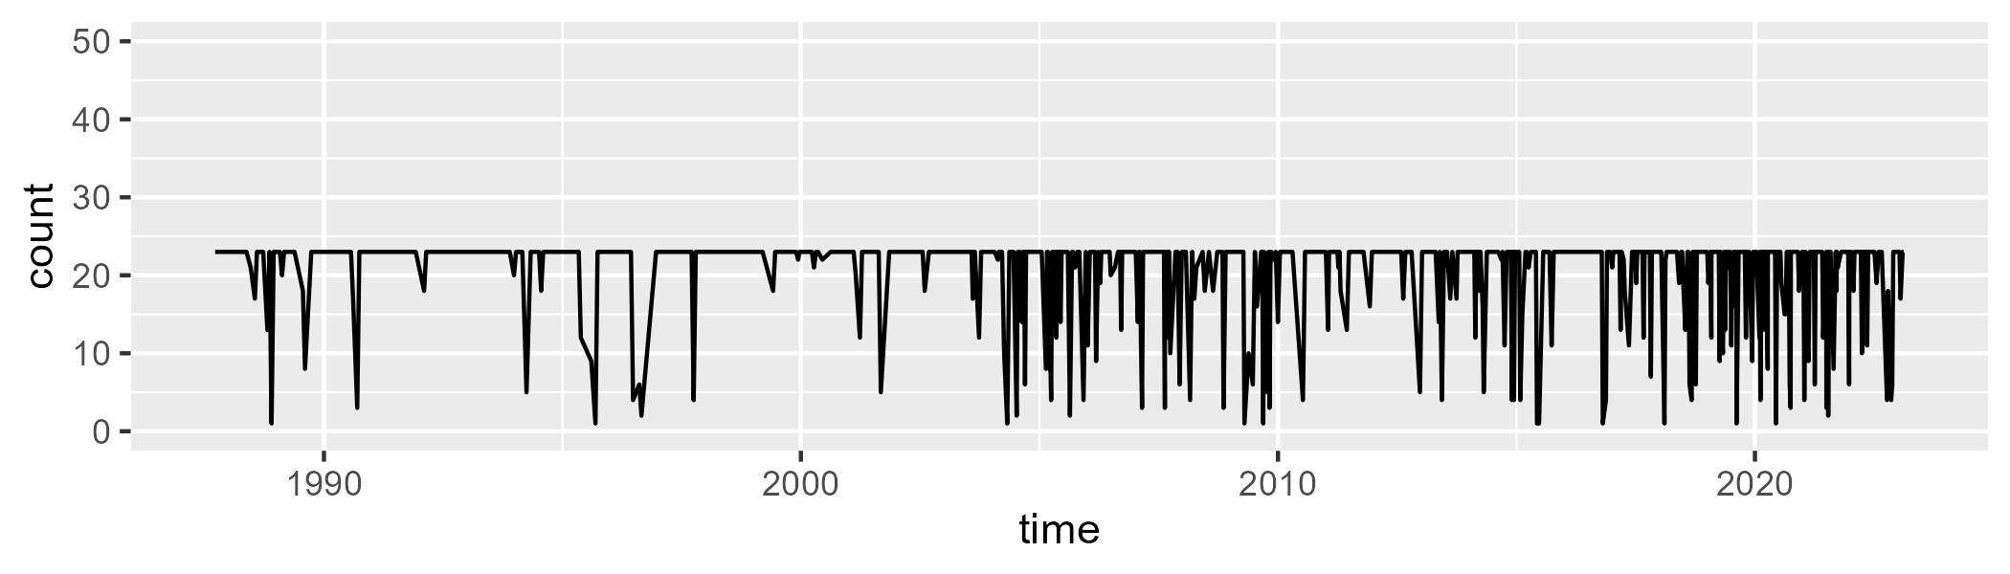

Min. : 1.0 1st Qu.:23.0 Median :23.0 Mean :20.5 3rd Qu.:23.0 Max. :23.0

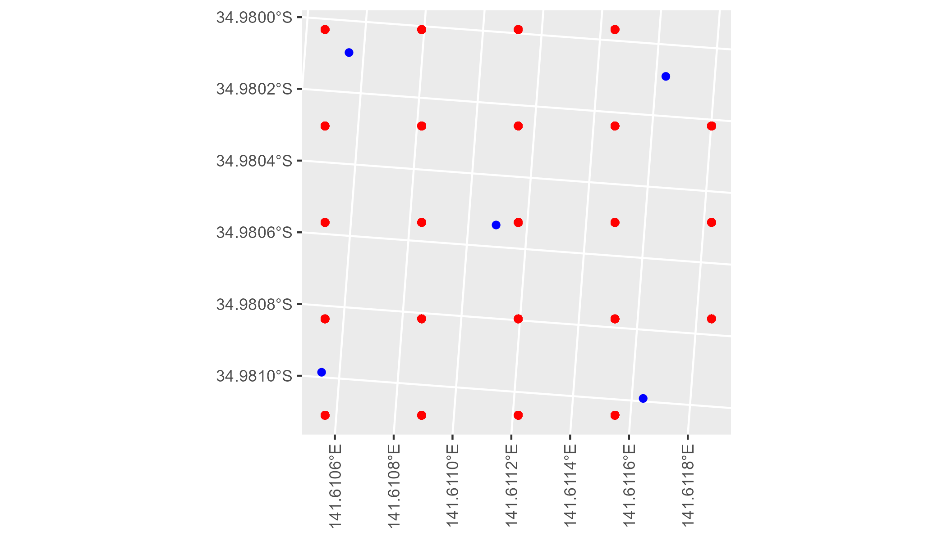

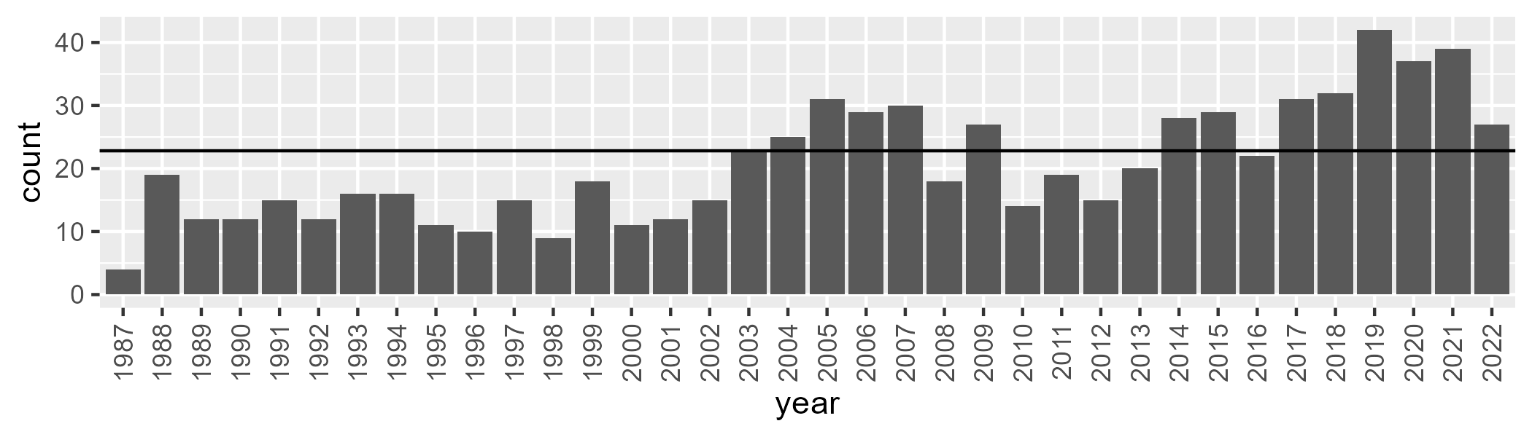

Number of samples: 745

# VCAMDD0002

| Min. | 1st Qu. | Median | Mean | 3rd Qu. | Max. |
| --- | --- | --- | --- | --- | --- |
| 8.647636 | 15.72913 | 20.73715 | 23.66798 | 29.98185 | 55.24542 |

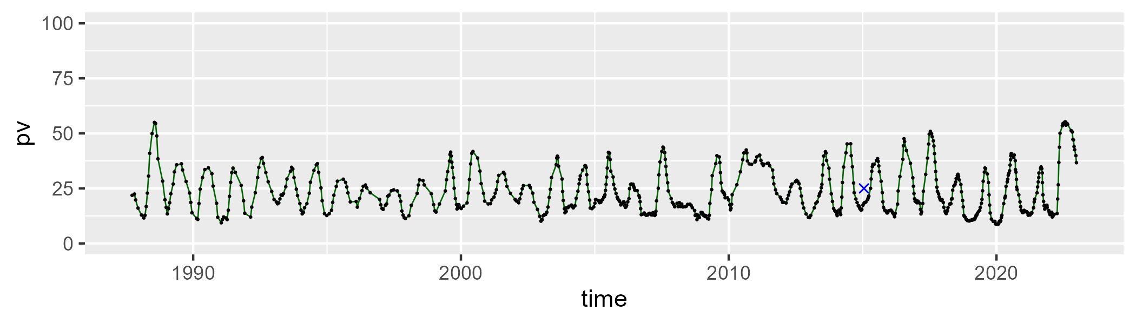

| Min. | 1st Qu. | Median | Mean | 3rd Qu. | Max. |
| --- | --- | --- | --- | --- | --- |
| 20.09917 | 51.98424 | 56.45981 | 55.78151 | 60.25513 | 68.15313 |

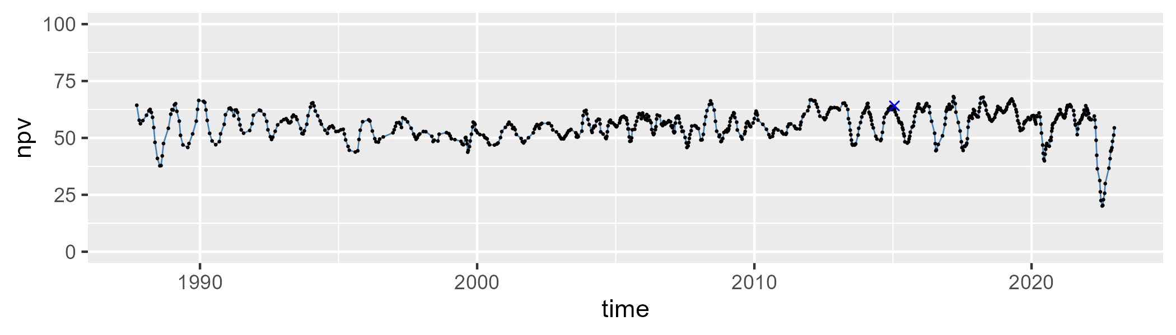

| Min. | 1st Qu. | Median | Mean | 3rd Qu. | Max. |
| --- | --- | --- | --- | --- | --- |
| 2.705639 | 14.0331 | 19.46936 | 19.332 | 24.1971 | 39.31459 |

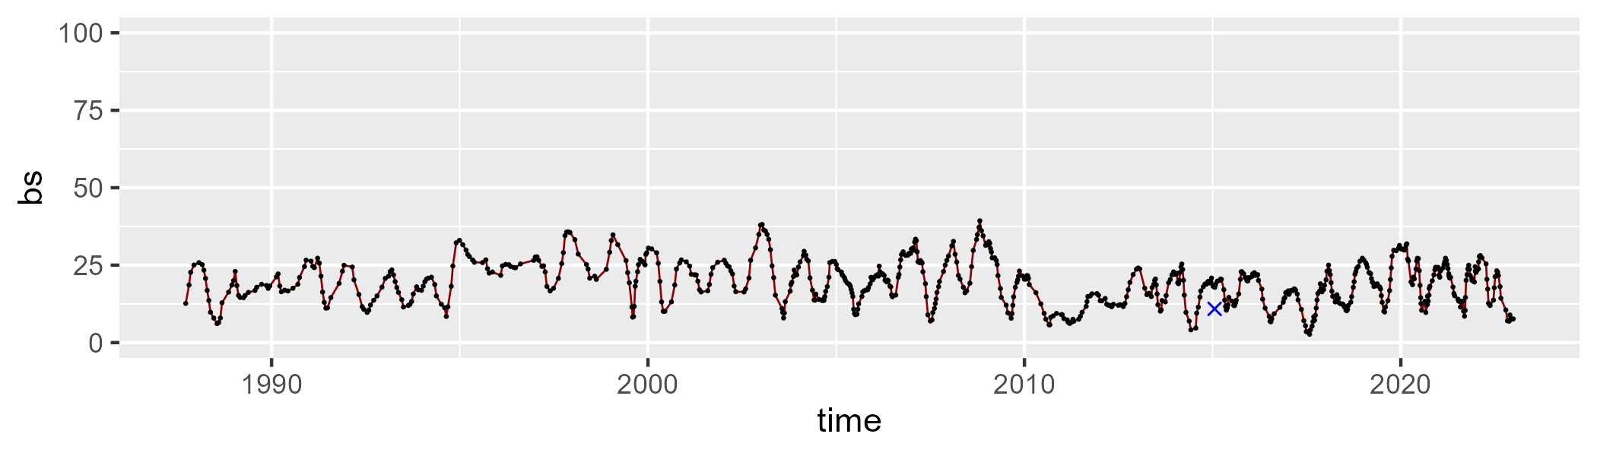

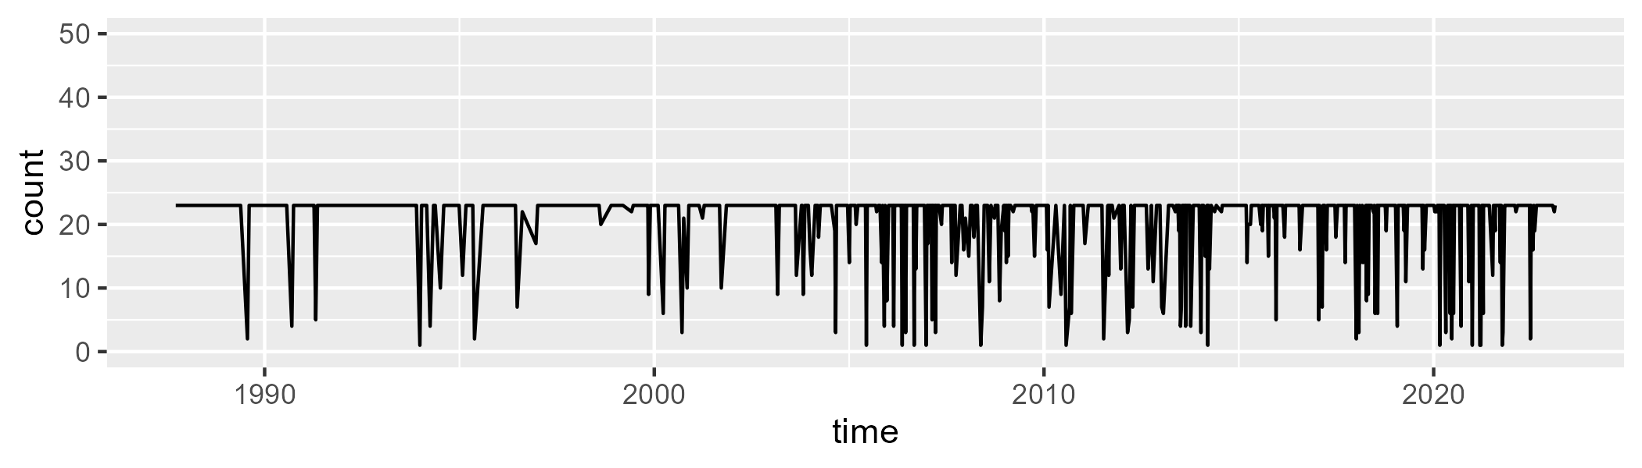

Min. : 1.00 1st Qu.:23.00 Median :23.00 Mean :20.63 3rd Qu.:23.00 Max. :23.00

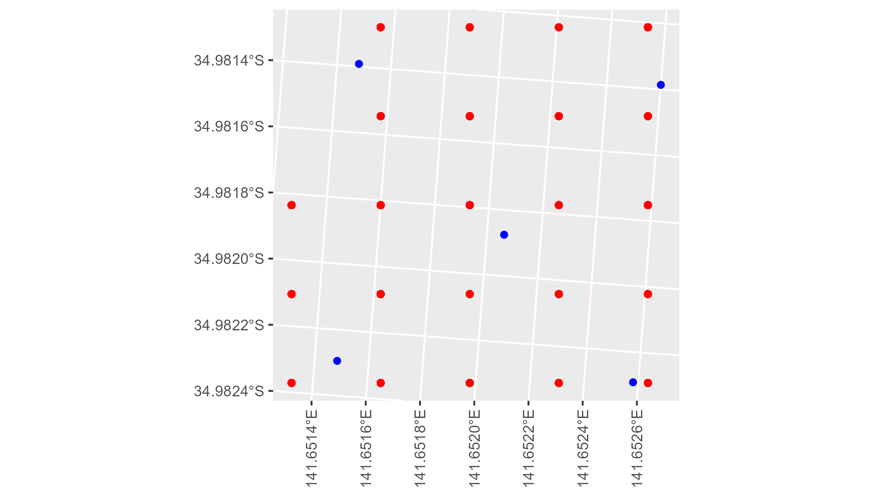

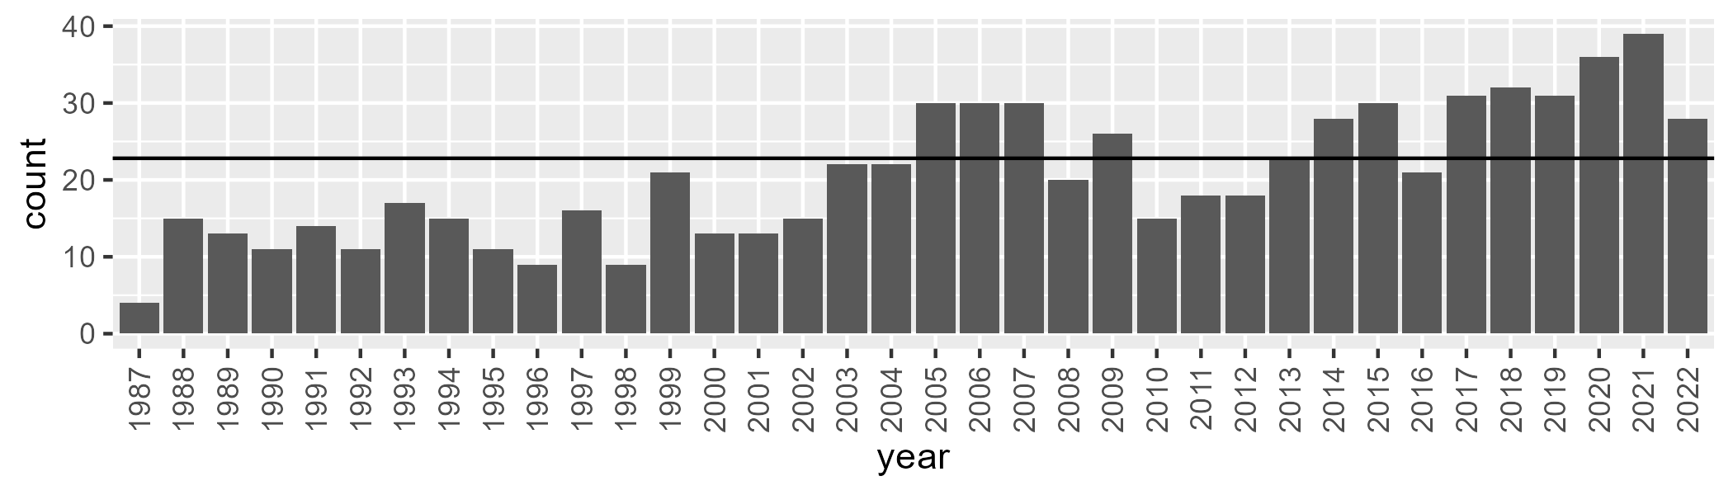

Number of samples: 737

# VCAMDD0003

| Min. | 1st Qu. | Median | Mean | 3rd Qu. | Max. |
| --- | --- | --- | --- | --- | --- |
| 16.01676 | 23.41121 | 27.56781 | 27.9251 | 31.93109 | 41.07176 |

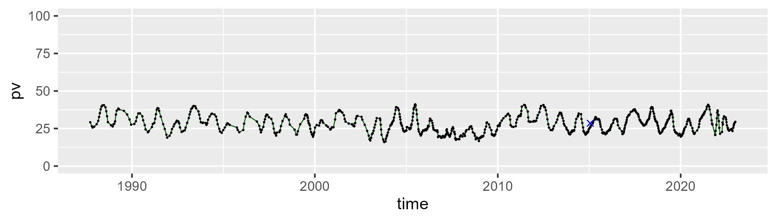

| Min. | 1st Qu. | Median | Mean | 3rd Qu. | Max. |
| --- | --- | --- | --- | --- | --- |
| 35.45005 | 45.75272 | 47.69317 | 47.43352 | 49.41212 | 61.08005 |

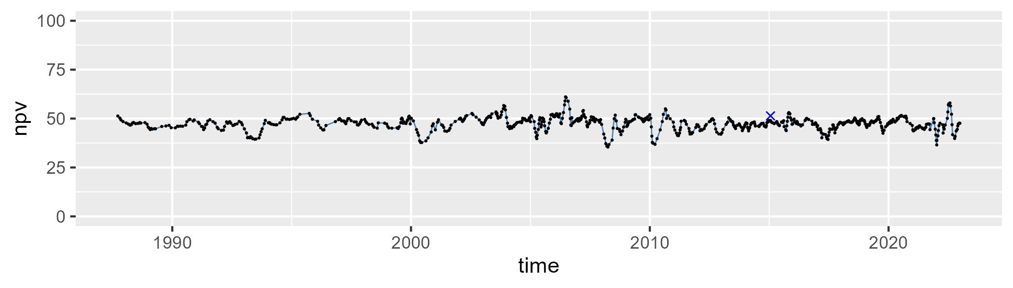

| Min. | 1st Qu. | Median | Mean | 3rd Qu. | Max. |
| --- | --- | --- | --- | --- | --- |
| 8.098438 | 19.42503 | 23.54442 | 23.36258 | 27.42459 | 42.86578 |

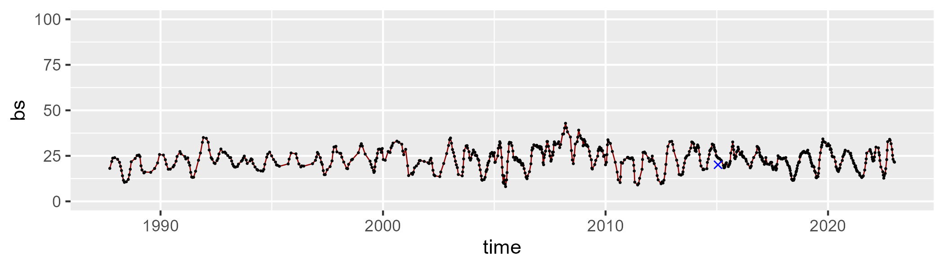

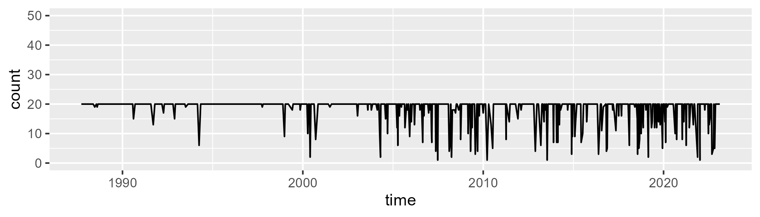

Min. : 1.00 1st Qu.:20.00 Median :20.00 Mean :18.44 3rd Qu.:20.00 Max. :20.00

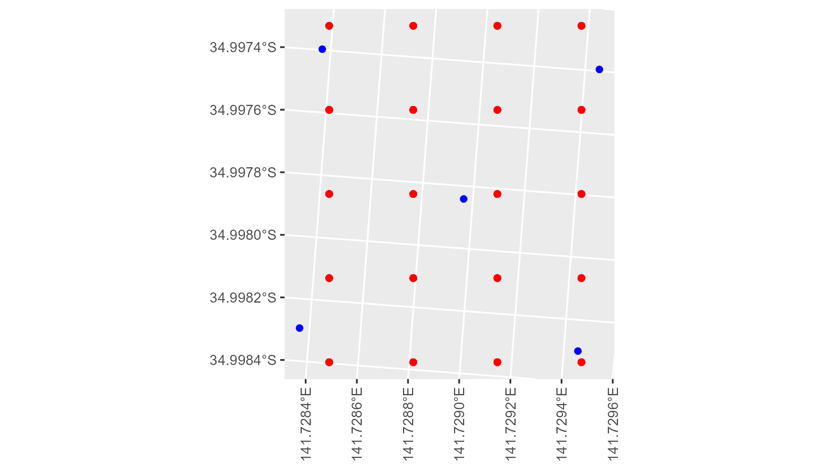

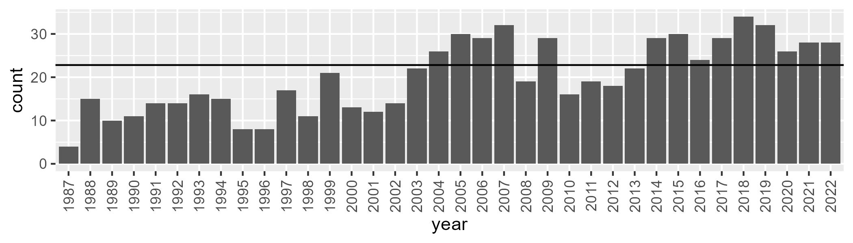

Number of samples: 725